**Module 8 Assignment: Final Project**

Nikita Goel

Arizona State University

IFT 598: Middleware Programming & Database Security

Professor. Dinesh Sthapit

December 03, 2022

**Requirements**

**A: User Interface**

1. **Create New User**

Flow diagram of creating new user (Figure 1)

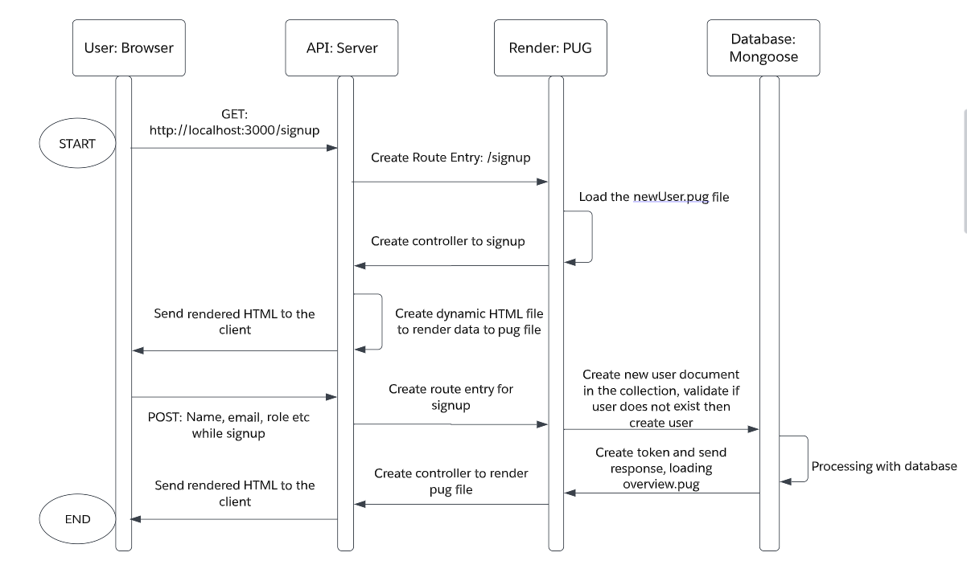

Figure 1: New user flow diagram

PUG file of newUser.pug (Figure 2)

**Code:**

extends baseTemplate

block content

  main.main

    .card-container

      .card

        .card__header

        .card__details

          h4.card__sub-heading New User

          p.card__text

            | Please enter the following Details

          .card__data

            svg.card__icon

              use(xlink:href='img/icons.svg#icon-map-pin')

            form(action='/api/v1/users/signup' method='post')

              label(for='name') Full name:

              input#name(type='text' name='name')

              br

              br

              label(for='email') Email:

              input#email(type='email' name='email')

              br

              br

              label(for='role') Role:

              br

              input#html(type='radio' name='role' value='user')

              label(for='role') User

              br

              input#html(type='radio' name='role' value='staff')

              label(for='role') Staff

              br

              input#html(type='radio' name='role' value='student')

              label(for='role') Student

              br

              input#html(type='radio' name='role' value='admin')

              label(for='role') Admin

              br

              br

              label(for='password') Password:

              input#password(type='password' name='password')

              br

              br

              label(for='passwordConfirm') Confirm Password:

              input#passwordConfirm(type='password' name='passwordConfirm')

              br

              br

              input.card__sub-heading(type='submit' value='Submit')

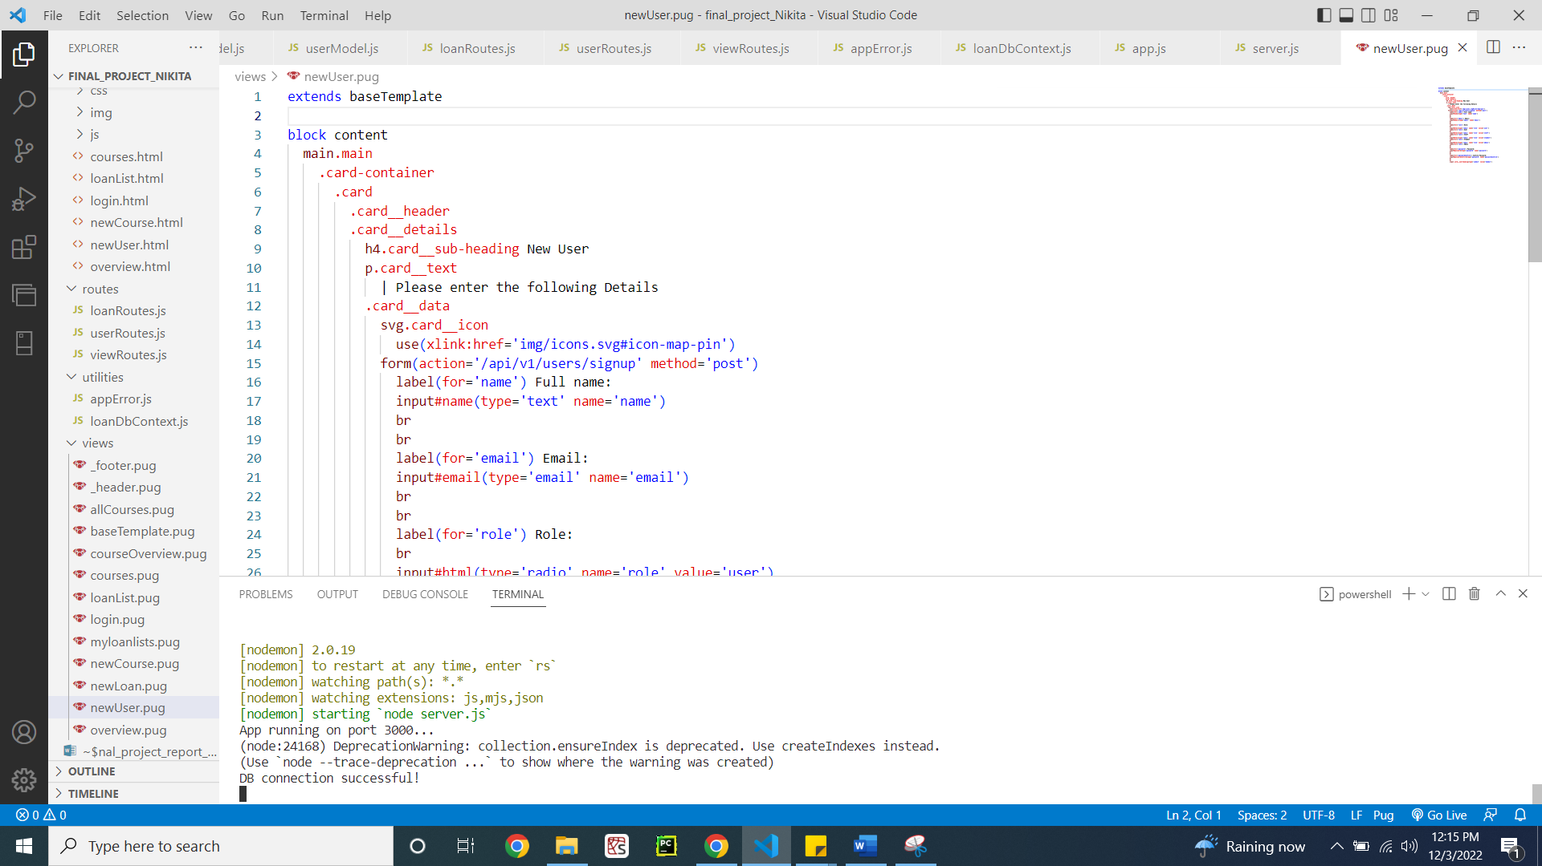

Figure 2: Code showing newUser.pug

Screenshot showing the user interface on the browser for new user sign up (Figure 3)

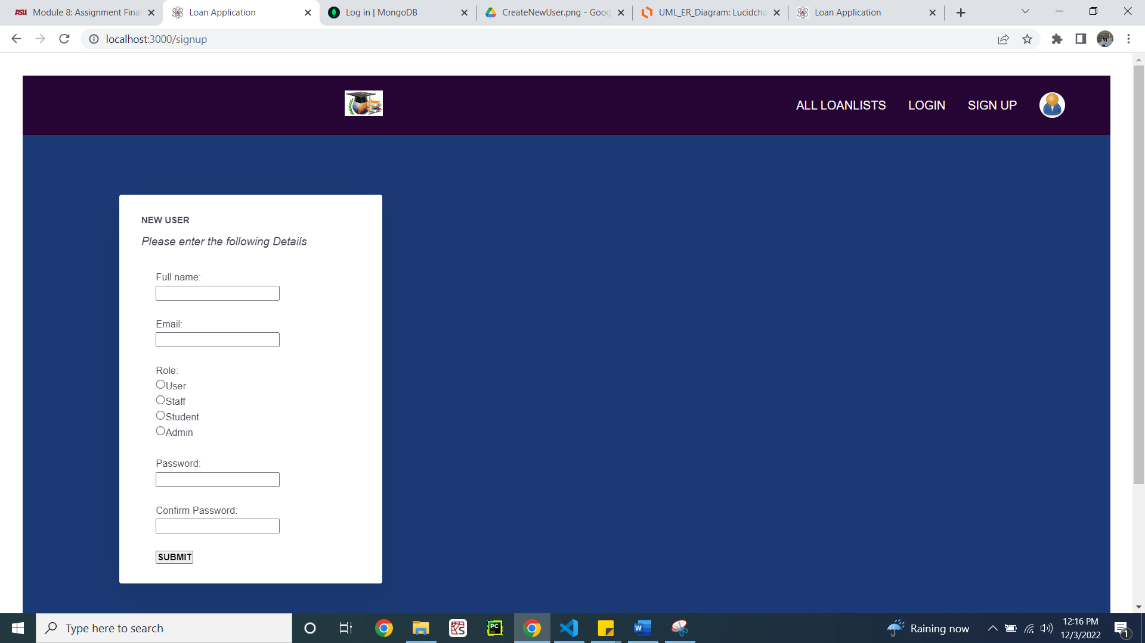

Figure 3: New user UI

1. **LogIn Current User**

Flow diagram of creating logging in the user (Figure 4)

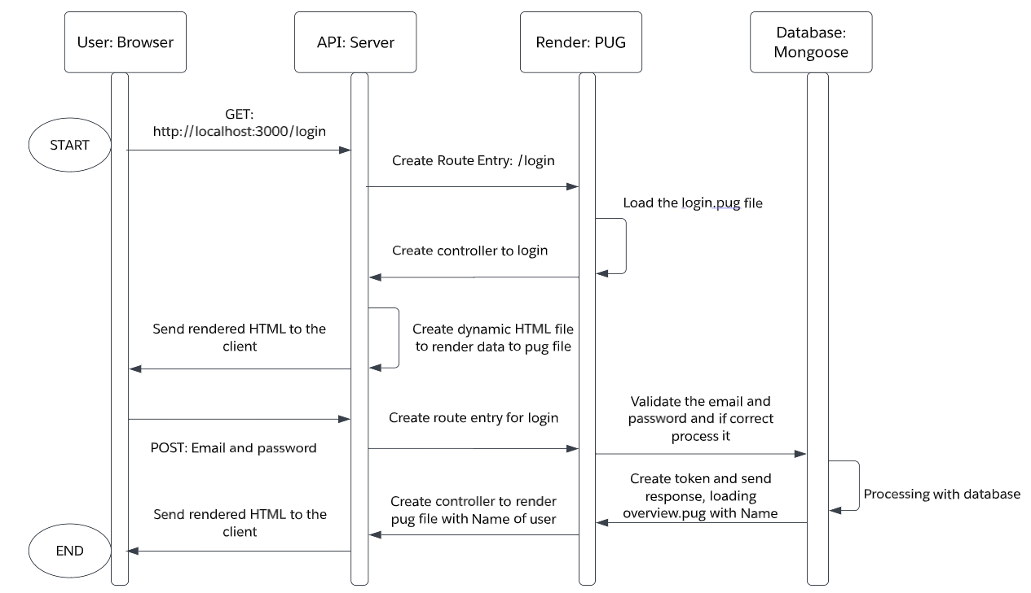

Figure 4: Login flow diagram

PUG file of login.pug (Figure 5)

**Code:**

extends baseTemplate

block content

    // LOGIN FORM

    main.main

      .card-container

        .card

          .card__header

            .card__details

              h1 Login

              p.card__text Please enter the following details

              .card__data

              form(action='/api/v1/users/login/' method='post')

                label(for='email') Email:

                br

                input(type='text' id='email' name='email')

                br

                br

                label(for='password') Password:

                br

                input(type='password' id='password' name='password')

                br

                br

                input.card__sub-heading( type='submit' value='Log In')

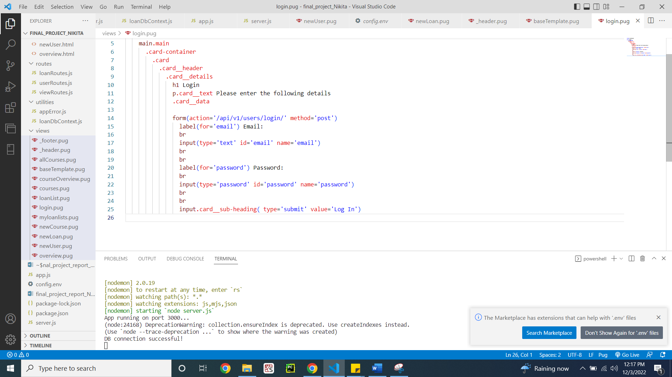

Figure 5: Code showing login.pug file

Screenshot showing the user interface on the browser for login (Figure 6)

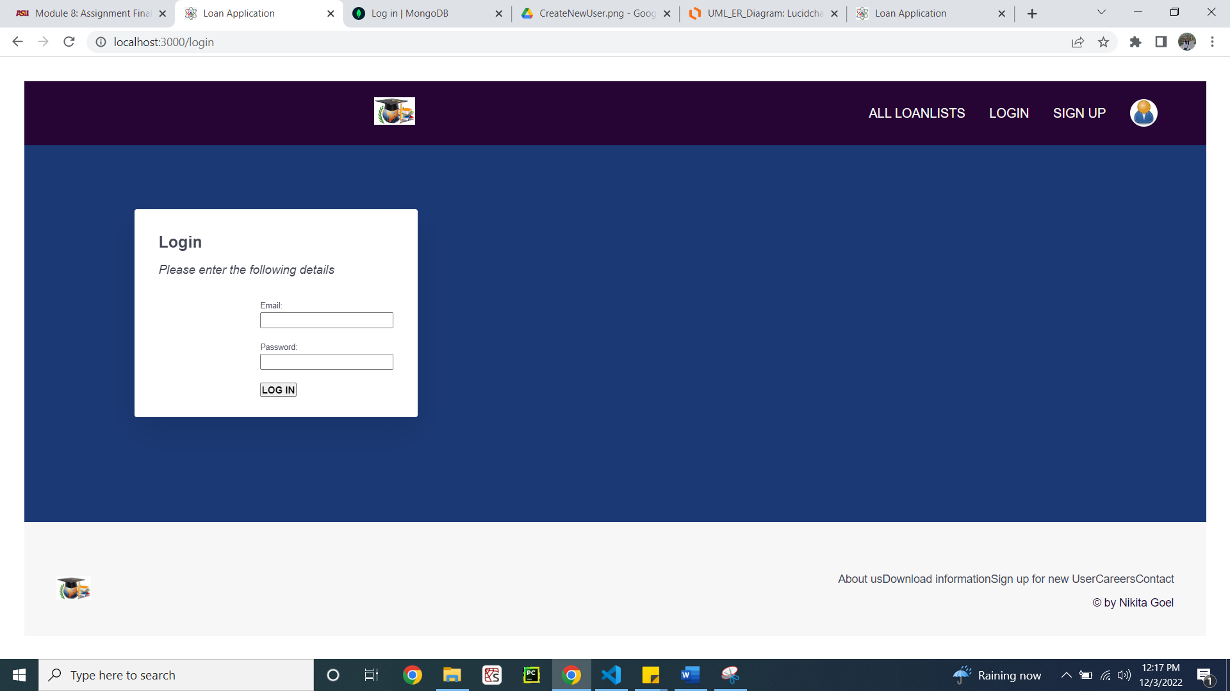

Figure 6: Login page UI

1. **Create New Loans**

Flow diagram showing the creation of new loan (Figure 7)

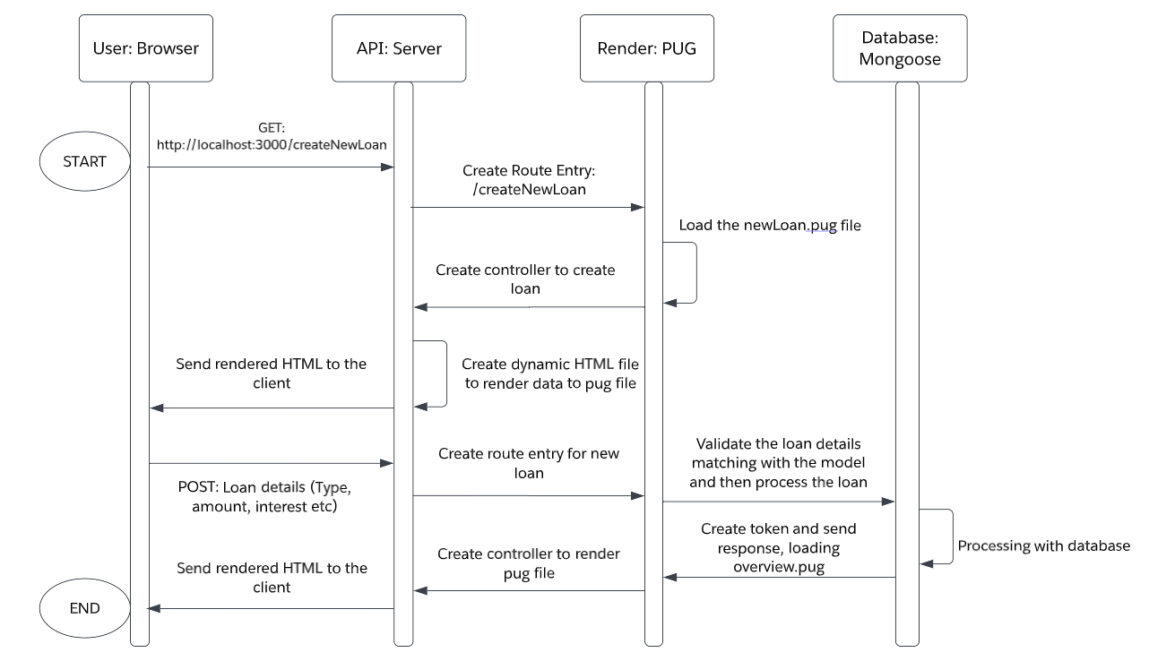

Figure 7: New loan flow diagram

PUG file showing code for newLoan.pug (Figure 8)

**Code:**

extends baseTemplate

block content

  h1 Create new loan

  main.main

    .card-container

      .card

        .card__header

          h3.heading-tertirary

            span Create a new loan

        .card__details

          h4.card__sub-heading New Loan information

          p.card__text

          |   Please enter the following Details

          .card__data

            svg.card__icon

              use(xlink:href='img/icons.svg#icon-map-pin')

            form(action='/api/v1/loans/' method='post')

              label(for='name') Name:

              input#name(type='text' name='name')

              br

              br

              label(for='loanType') Loan Type:

              br

              input#html(type='radio' name='loanType' value='Car')

              label(for='loanType') Car

              br

              input#html(type='radio' name='loanType' value='Home')

              label(for='loanType') Home

              br

              input#html(type='radio' name='loanType' value='Personal')

              label(for='loanType') Personal

              br

              input#html(type='radio' name='loanType' value='Education')

              label(for='loanType') Education

              br

              br

              label(for='startDate') startDate:

              input#startDate(type='text' name='startDate')

              br

              br

              label(for='loanTermYears') loanTermYears:

              input#loanTermYears(type='text' name='loanTermYears')

              br

              br

              label(for='phoneNumber') Phone Number:

              input#phoneNumber(type='text' name='phoneNumber')

              br

              br

              label(for='loanAmount') Amount:

              input#loanAmount(type='text' name='loanAmount')

              label(for='interest') interestRate:

              input#interest(type='text' name='interest')

              br

              br

              input.card__sub-heading(type='submit' value='Submit')

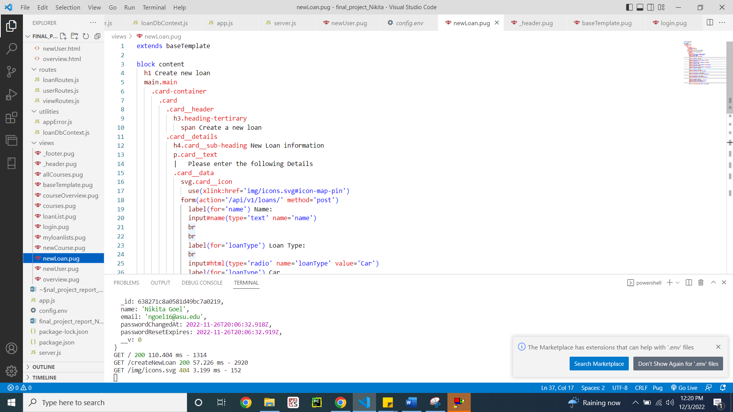

Figure 8: Showing code of newLoan.pug file

Screenshot showing the user interface of new loan creation page (Figure 9)

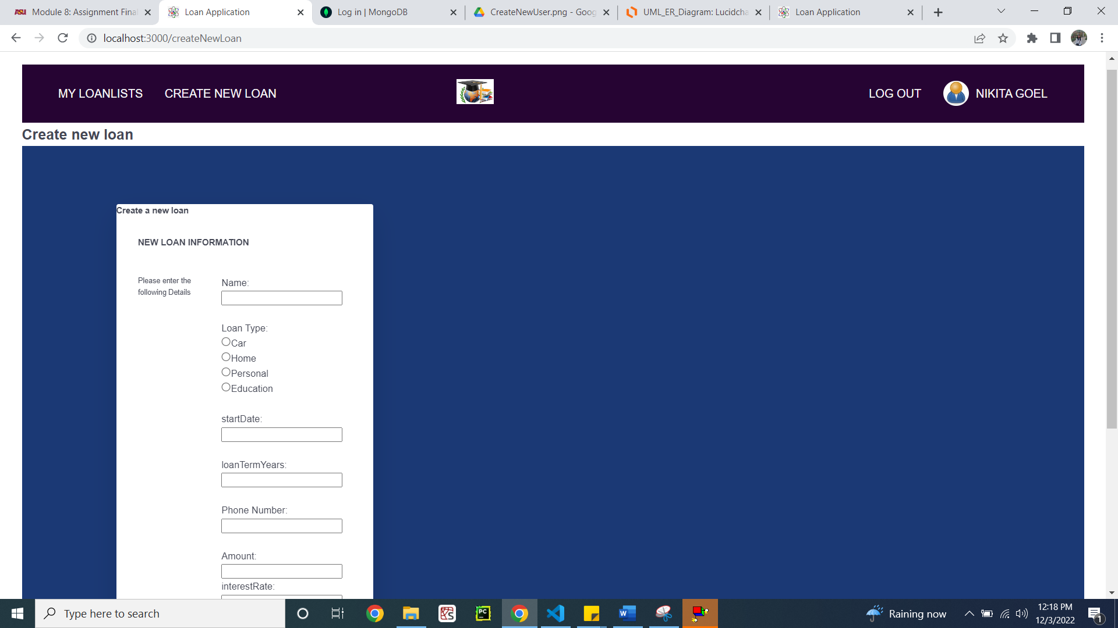

Figure 9.1: UI for new loan creation page

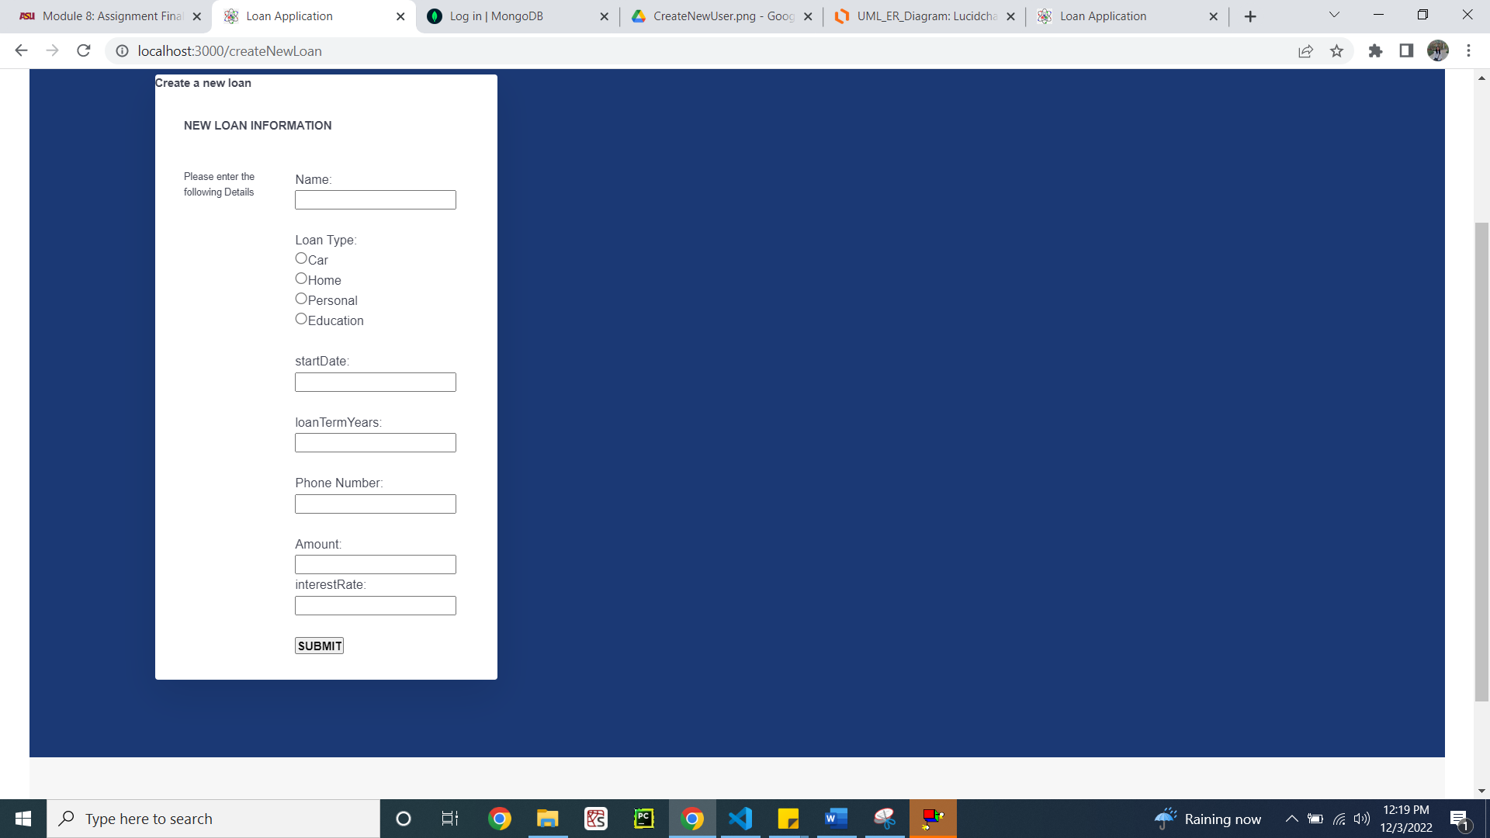

Figure 9.2: Page continued

1. **List Loan Details**

Flow diagram showing list of all loans (Figure 10)

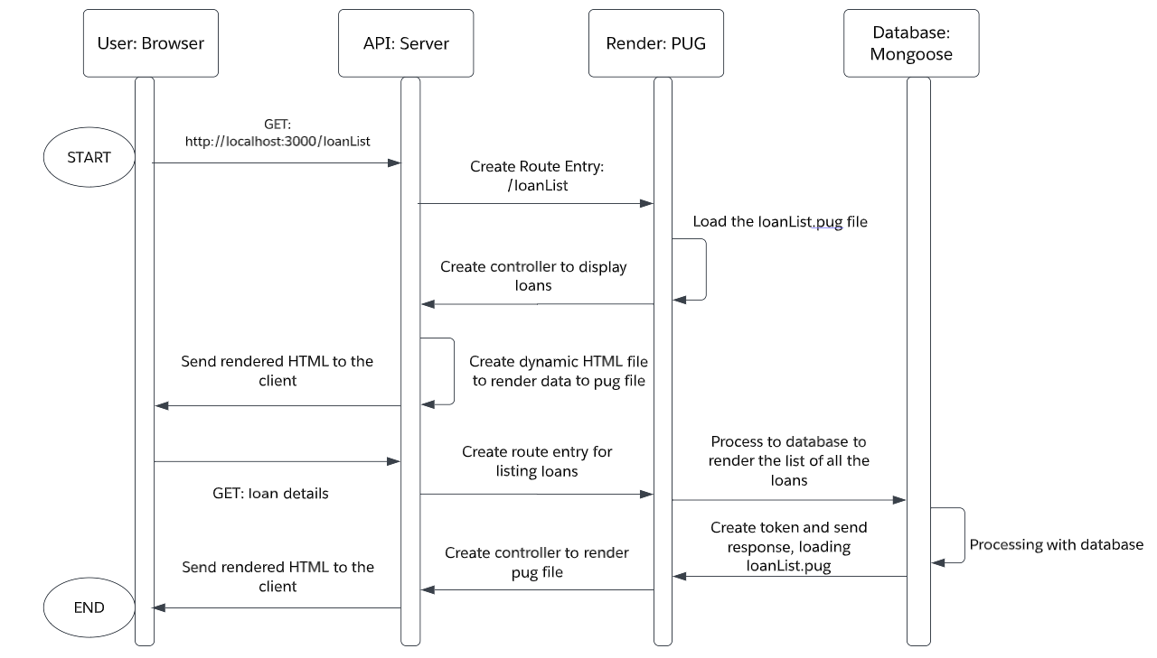

Figure 10: List all loans flow diagram

PUG file of UI code for listing all the loans (Figure 11)

**Code:**

extends baseTemplate

block content

  h1

    span List of Loans

  table.table-header

    thead

      tr

        th(scope='col') Name

        th(scope='col') Type of Loan

        th(scope='col') Phone Number

        th(scope='col') Amount

        th(scope='col') Interest Rate (%)

        th(scope='col') Term (Yrs)

    tbody

      each loan in loans

        tr.table-secondary

          td=loan.name

          td=loan.loanType

          td=loan.phoneNumber

          td=loan.loanAmount

          td=loan.interest

          td=loan.loanTermYears

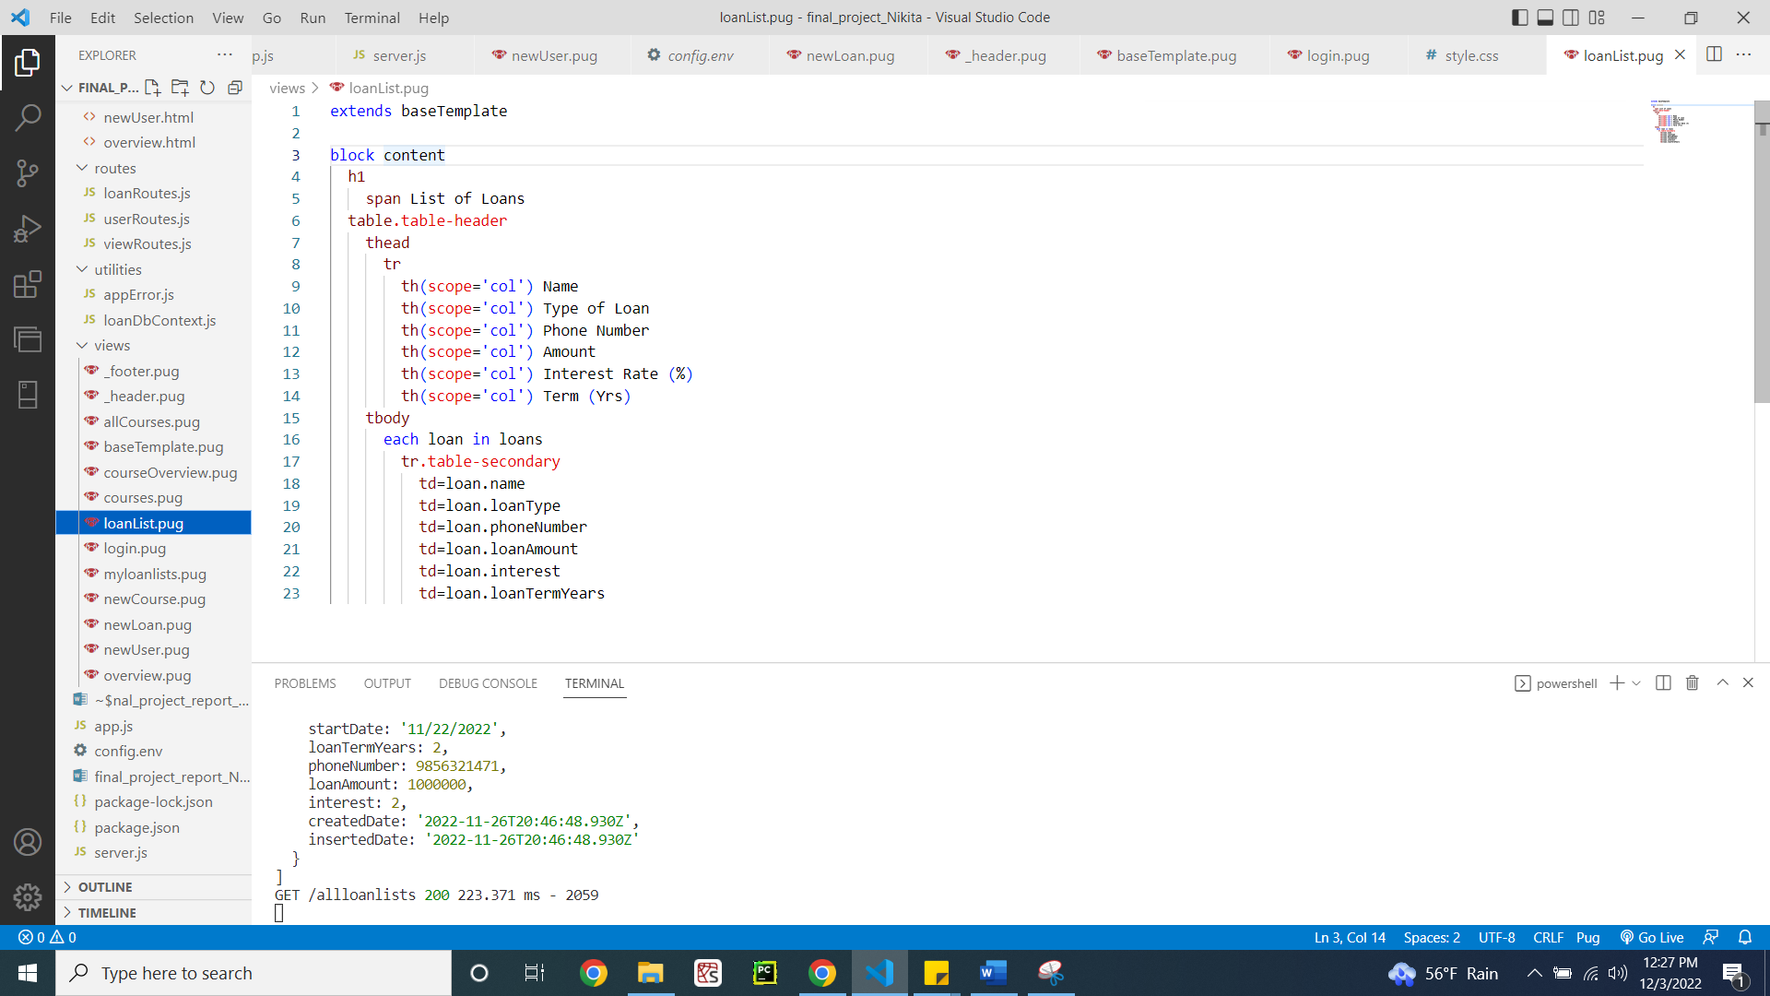

Figure 11: Code showing the loanList.pug file

Screenshot showing user interface of listing all the loans from the database (Figure 12)

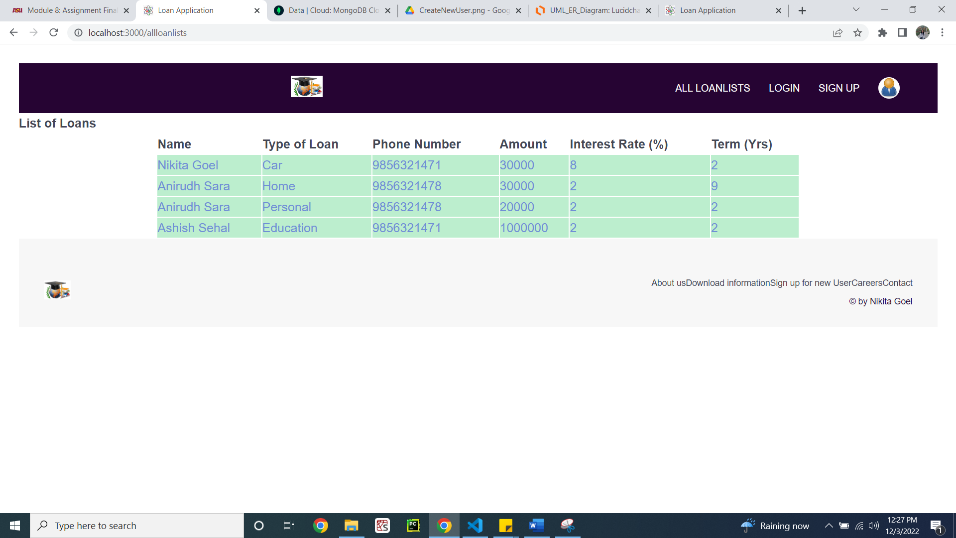

Figure 12: Listing all the loans UI page

**B: Middleware API**

1. **Create New User**

viewRoutes.js file showing the route for signing up the new user (Figure 13)

**Code:**

/*

Name: Nikita Goel

Date: 3rd December, 2022

Description: This file manages all the routes containing  get requests for all the pages

*/

const express = require('express');

const viewsController = require('../controllers/viewsController');

const router = express.Router();

router.get('/', viewsController.home);

router.get('/myloanlists', viewsController.getMyLoan);

router.get('/allloanlists', viewsController.getLoan);

router.get('/createNewLoan', viewsController.CreateNewLoan);

router.get('/loanList', viewsController.getMyLoan);

router.get('/logout', viewsController.logout);

router.get('/login', viewsController.getLoginForm);

router.get('/signup', viewsController.getSignInForm);

// router.get('/courses', viewsController.getCourse);

// router.get('/newCourse', viewsController.createNewCourse);

// router.get('/courseList', viewsController.getCoursesJSON);

//router.get('/alluserlists', viewsController.getAllUser);

module.exports = router;

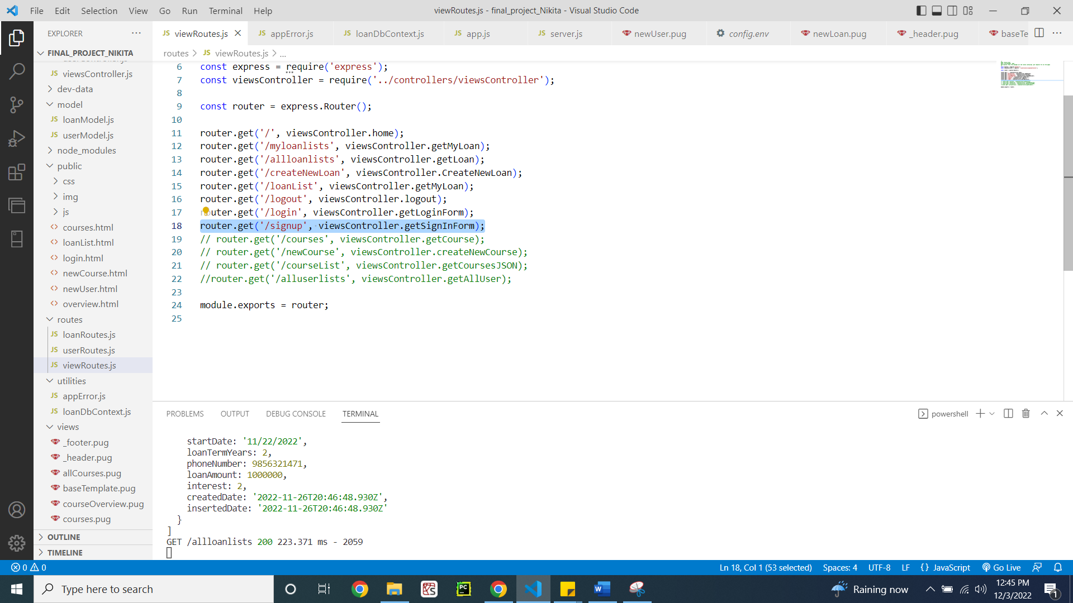

Figure 13: viewRoutes.js file

viewController.js file that gets invoked when the view route is called (Figure 14)

**Code:**

/*

Name: Nikita Goel

Date: 3rd December, 2022

Description: This file is setting controller for all the view routes for signing up and login of users, getting home screen and managing logout

*/

const axios = require('axios');

const User = require('./../model/userModel');

exports.getLoginForm = (req, res) => {

  res.status(200).render('login', {

    title: 'Log into your account'

  });

};

exports.getSignInForm = (req, res) => {

  res.status(200).render('newUser', {

    title: 'Sign in New User'

  });

};

exports.getCourse = async (req, res) => {

  res.status(200).render('courses', {

    title: `Get Course`

  });

};

exports.createNewCourse = async (req, res) => {

  res.status(200).render('newCourse', {

    title: `Create New Course`

  });

};

// adding the loan list for the views

exports.getLoan = async (req, res) => {

  const query = await axios.get('http://localhost:3000/api/v1/loans')

  console.log(query.data.loans)

  res.status(200).render('loanlist', {

    title: `Get loanlists`,

    "loans": query.data.loans

  });

};

exports.getCoursesJSON = async (req, res) => {

  res.status(200).render('allCourses', {

    title: `Get courses from JSON`,

    "courses": courses

  });

};

exports.home = async (req, res) => {

  if (req.session.userId){

    User.findById(req.session.userId)

    .exec(function (error, user) {

      console.log(user)

      if (error) {

        res.status(200).render('overview', {

          title: `Over View`

        });

      } else {

        return res.render('overview', { title: 'Over View', name: user.name});

      }

      req.session.name = user.name

    });

  }

  else {

    res.status(200).render('overview', {

    title: `Over View`

  });

  }

};

exports.getMyLoan = async (req, res) => {

  // console.log(req.session)

  const query = await axios.get('http://localhost:3000/api/v1/loans/My',{params:{name:req.session.name}})

  // console.log(query.data.loans)

  res.status(200).render('myloanlists', {

    title: `Get loanlists`,

    "loans": query.data.loans,

    name: req.session.name

  });

};

exports.CreateNewLoan = (req, res) => {

  res.status(200).render('newLoan', {

    title: 'Create New Loan',

    name: req.session.name

  });

};

exports.logout = (req, res) => {

  if (req.session) {

    // delete session object

    req.session.destroy(function(err) {

      if(err) {

        return next(err);

      } else {

        return res.redirect('/');

      }

    });

  }

};

// commented the code as it is not in the requirements

// exports.getAllUser = async (req, res) => {

//   // console.log(req.session)

//   const query = await axios.get('http://localhost:3000/api/v1/users/')

//   // console.log(query.data)

//   res.status(200).render('alluserlists', {

//     title: `Get userlists`,

//     "users": query.data.users,

//     name: req.session.name

//   });

// };

// exports.getLoginUser = (req, res) => {

//   const {email, password} = req.body;

//   res.status(200).render('login', {

//     title: 'Log into your account'

//   });

// };

// exports.getLandingPAge = async (req, res) => {

//   res.status(200).render('overview', {

//     title: `Over View`

//   });

// };

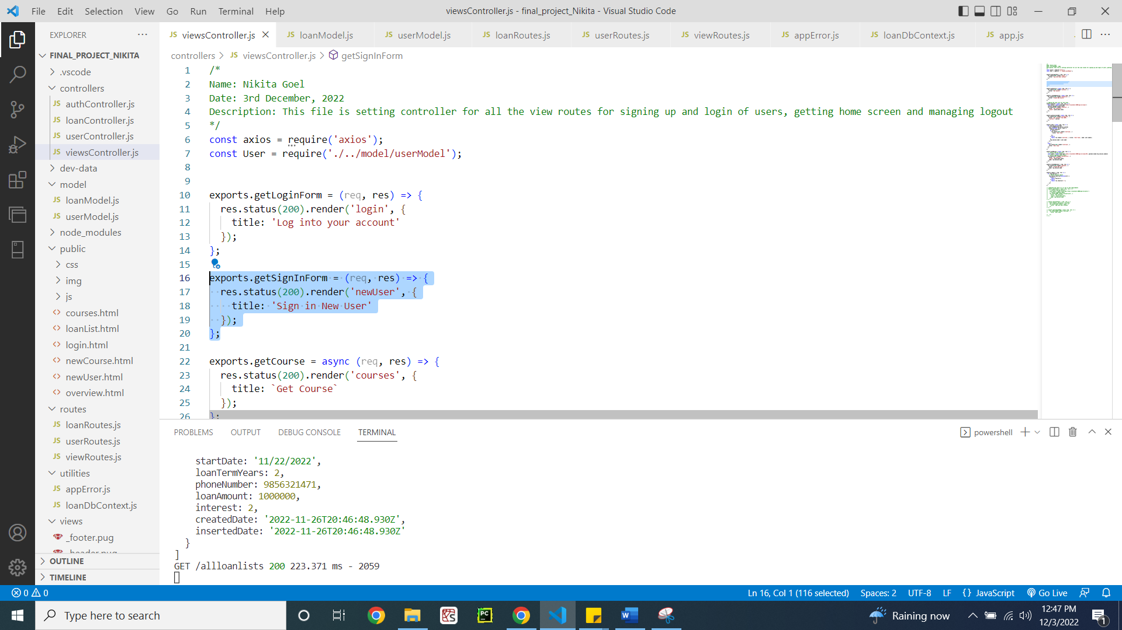

Figure 14: Sign up function that renders the sign up page

After the pug file sends the route to the userRoutes.js file (Figure 15)

**Code:**

/*

Name: Nikita Goel

Date: 3rd December, 2022

Description: This file manages all the routes containing post and get requests for user routes

*/

const express = require('express');

const userController = require('./../controllers/userController');

const authController = require('./../controllers/authController');

const router = express.Router();

router.post('/login', authController.login);

router.post('/signup', authController.signup);

router.get('/logout', authController.logout);

router

  .route('/')

  .post(userController.createUser);

//  .get(userController.getAllUsers)

router

  .route('/:id')

  .get(userController.getUser)

  .patch(userController.updateUser);

module.exports = router;

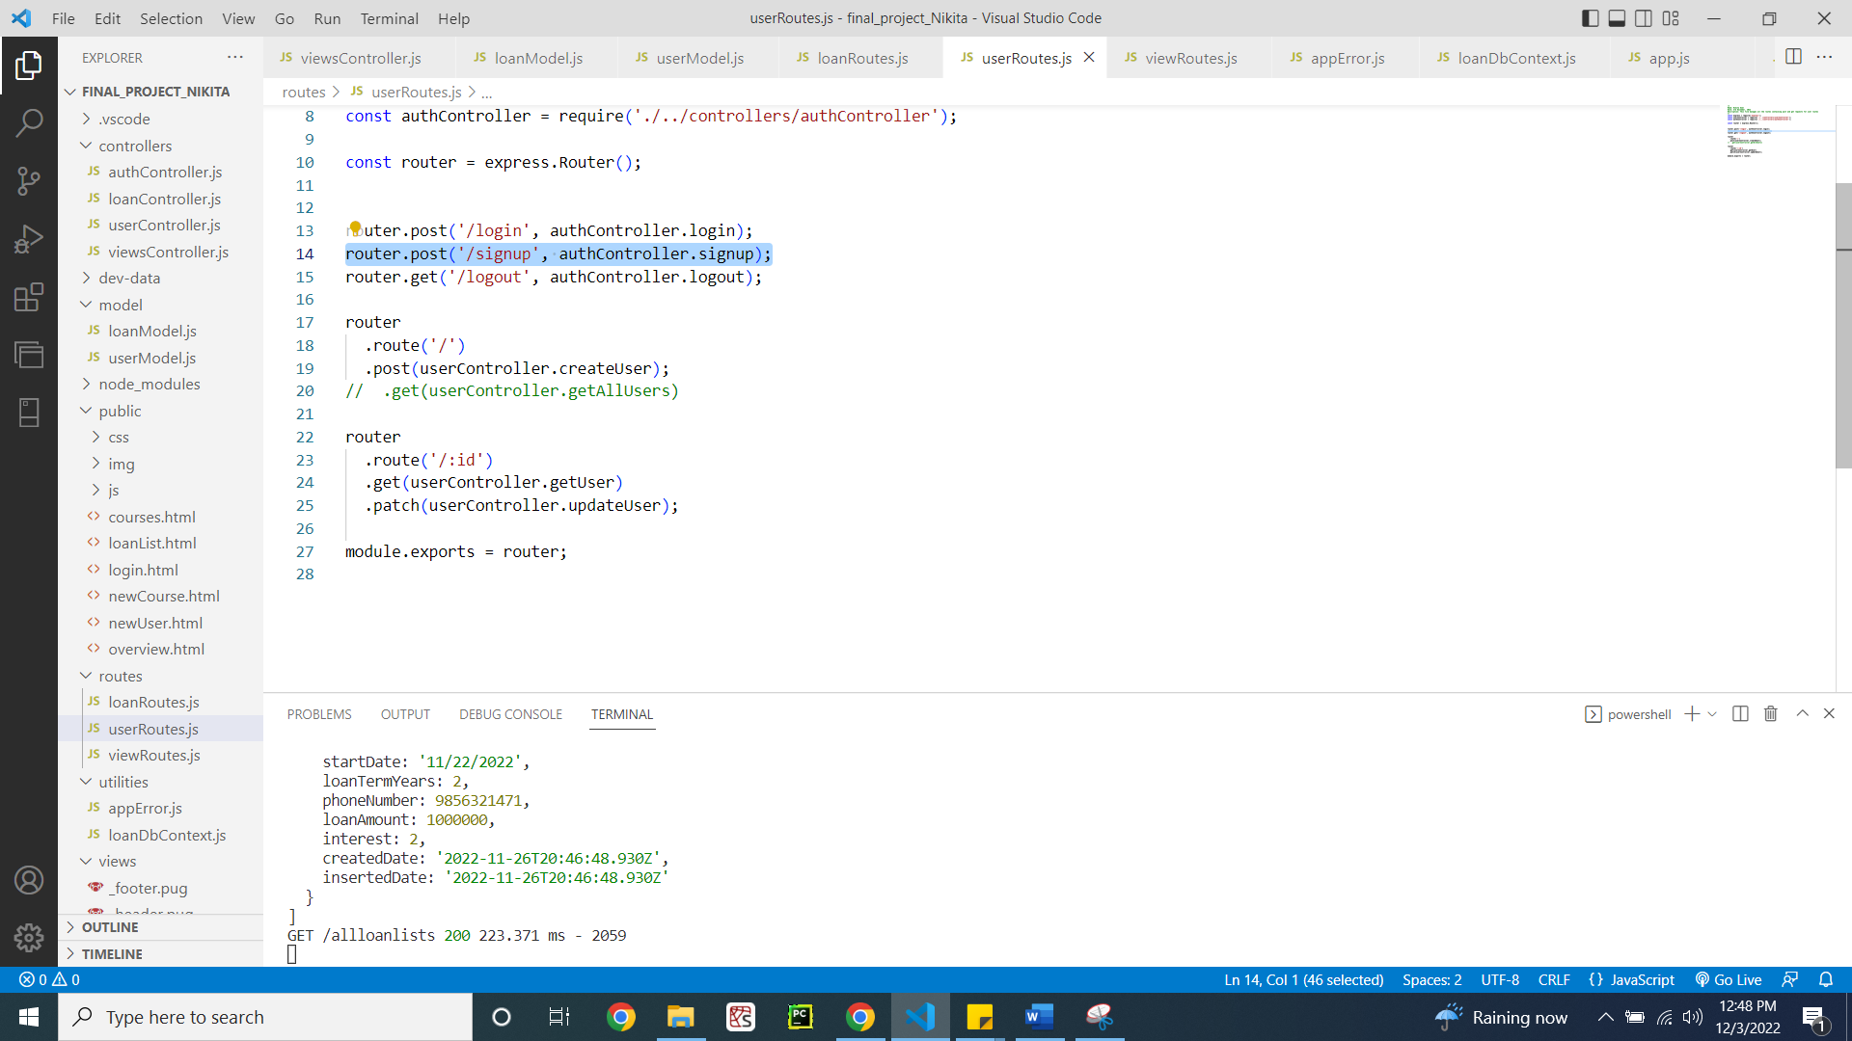

Figure 15: userRoutes.js file

Authentication file showing the functionality for signing up new user (Figure 16)

**Code:**

/*

Name: Nikita Goel

Date: 3rd December, 2022

Description: This file authenticates the user login and logout and creation of user securely

*/

const crypto = require('crypto');

const jwt = require('jsonwebtoken');

const User = require('./../model/userModel');

const AppError = require('./../utilities/appError');

const util = require('util');

const express = require('express');

const alert =require('alert')

require('util.promisify').shim();

const signToken = id => {

  return jwt.sign({ id }, process.env.JWT_SECRET, {

    expiresIn: process.env.JWT_EXPIRES_IN

  });

};

const createSendToken = (user, statusCode, res) => {

  const token = signToken(user._id);

  const cookieOptions = {

    expires: new Date(

      Date.now() + process.env.JWT_COOKIE_EXPIRES_IN * 24 * 60 * 60 * 1000

    ),

    httpOnly: true

  };

  if (process.env.NODE_ENV === 'production') {

    cookieOptions.secure = true;

  }

  res.cookie('jwt', token, cookieOptions);

  // Remove password from output

  user.password = undefined;

};

exports.signup = async (req, res, next) => {

  console.log(req.body)

  const newUser = await User.create({

    name: req.body.name,

    email: req.body.email,

    password: req.body.password,

    passwordConfirm: req.body.passwordConfirm,

    role: req.body.role

  });

  createSendToken(newUser, 201, res);

  console.log('sign up successfully')

  req.session.email = newUser.email

  req.session.name = newUser.name

  req.session.userId = newUser._id;

  res.redirect('/')

};

exports.login = async (req, res, next) => {

  const { email, password } = req.body;

  // 1) Check if email and password exist

  if (!email || !password) {

    return next(new AppError('Please provide email and password!', 400));

  }

  //authentication

  // 2) Check if user exists && password is correct

  const user = await User.findOne({ email }).select('+password');

  if (!user || !(user.correctPassword(password, user.password))) {

    return next(new AppError('Incorrect email or password', 401));

  }

  //end of authentication

  // 3) If everything ok, send token to client

  createSendToken(user, 200, res);

  req.session.email = user.email

  req.session.name = user.name

  req.session.userId = user._id;

  alert("successfully!!!")

  res.redirect('/')

};

exports.logout = (req, res) => {

  res.cookie('jwt', 'loggedout', {

    expires: new Date(Date.now() + 10 * 1000),

    httpOnly: true

  });

  res.status(200).json({ status: 'success' });

};

exports.protect = async (req, res, next) => {

  // 1) Getting token and check of it's there

  let token;

  if (

    req.headers.authorization &&

    req.headers.authorization.startsWith('Bearer')

  ) {

    token = req.headers.authorization.split(' ')[1];

  } else if (req.cookies.jwt) {

    token = req.cookies.jwt;

  }

  if (!token) {

    return next(

      new AppError('You are not logged in! Please log in to get access.', 401)

    );

  }

  // 2) Verification token

  const decoded = await util.promisify(jwt.verify)(token, process.env.JWT_SECRET);

  // 3) Check if user still exists

  const currentUser = await User.findById(decoded.id);

  if (!currentUser) {

    return next(

      new AppError(

        'The user belonging to this token does no longer exist.',

        401

      )

    );

  }

  // 4) Check if user changed password after the token was issued

  if (currentUser.changedPasswordAfter(decoded.iat)) {

    return next(

      new AppError('User recently changed password! Please log in again.', 401)

    );

  }

  // GRANT ACCESS TO PROTECTED ROUTE

  req.user = currentUser;

  res.locals.user = currentUser;

  next();

  res.status(201).json({

    status: 'success',

    token,

    data: {

      currentUser

    }

  });

};

// Only for rendered pages, no errors!

exports.isLoggedIn = async (req, res, next) => {

  if (req.cookies.jwt) {

    try {

      // 1) verify token

      const decoded = await promisify(jwt.verify)(

        req.cookies.jwt,

        process.env.JWT_SECRET

      );

      // 2) Check if user still exists

      const currentUser = await User.findById(decoded.id);

      if (!currentUser) {

        return next();

      }

      // 3) Check if user changed password after the token was issued

      if (currentUser.changedPasswordAfter(decoded.iat)) {

        return next();

      }

      // THERE IS A LOGGED IN USER

      res.locals.user = currentUser;

      return next();

    } catch (err) {

      return next();

    }

  }

  next();

};

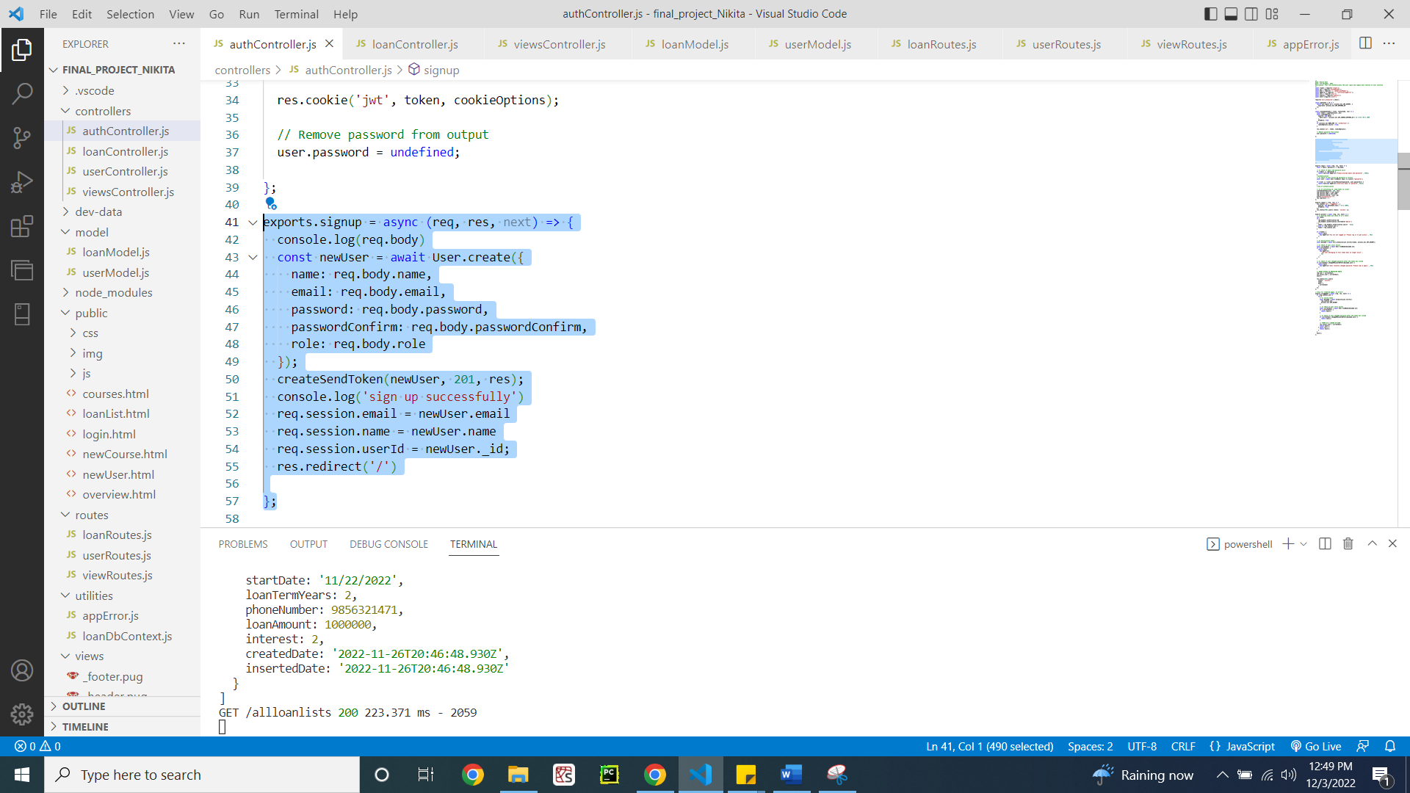

Figure 16: authController.js file

1. **LogIn Current User**

viewRoutes.js file with the log in route (Figure 17)

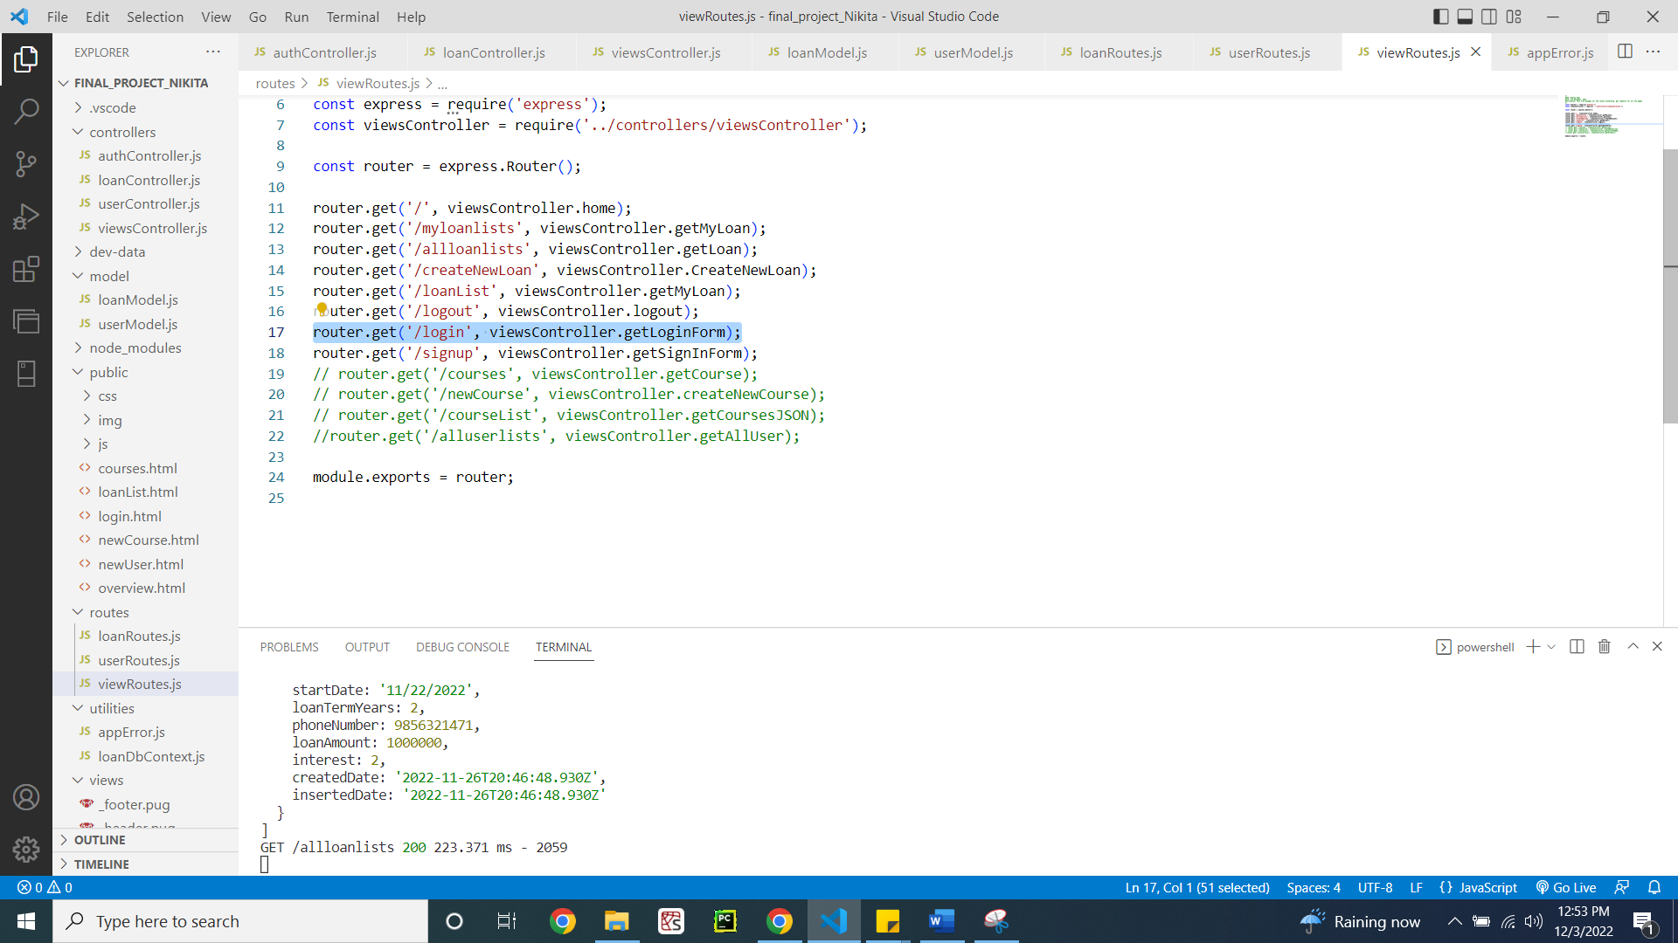

Figure 17: viewRoutes.js file for login

viewController.js file when the log in route is invoked (Figure 18)

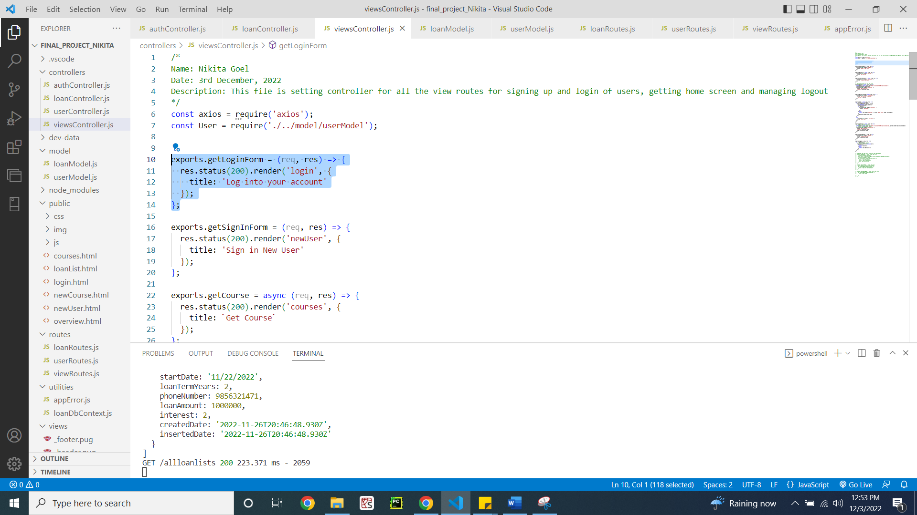

Figure 18: viewController.js file for login

userRoutes.js file with the log in route after HTML file is invoked (Figure 19)

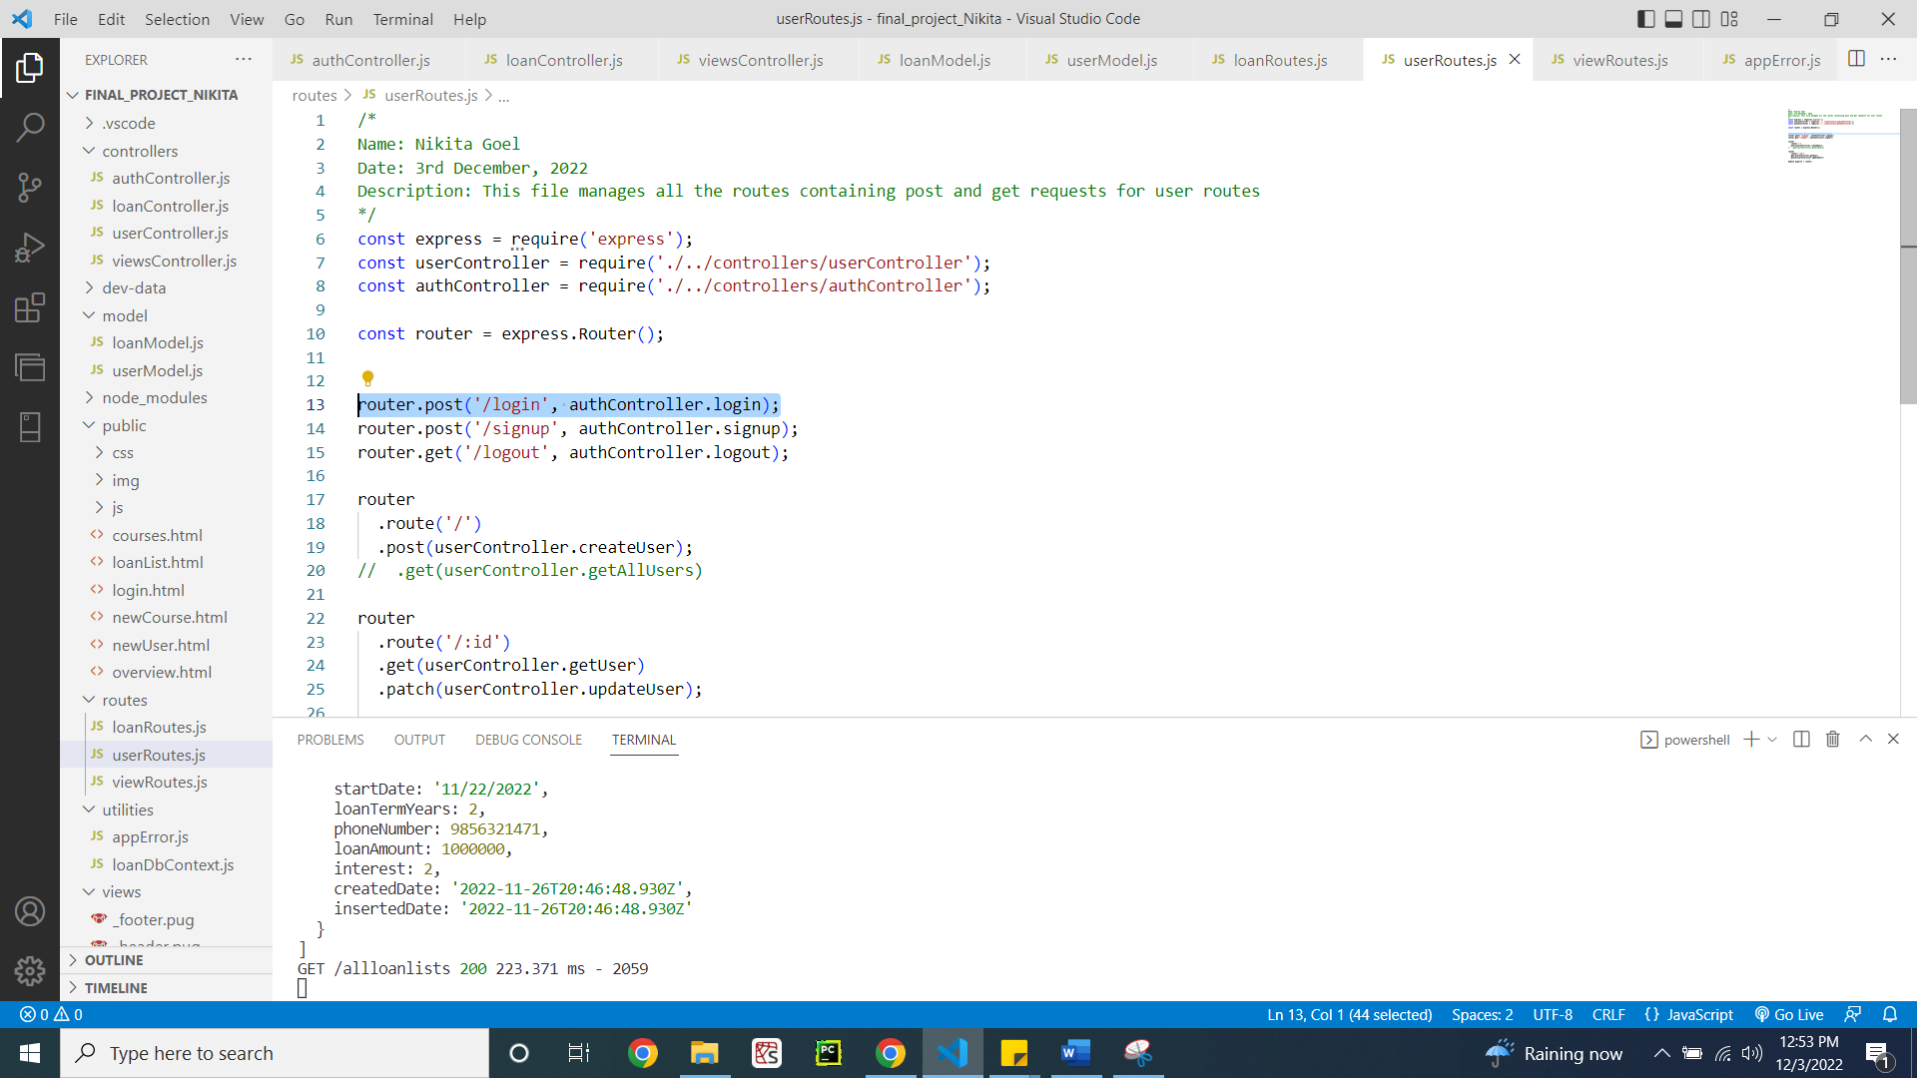

Figure 19: userRoutes.js file for login

authController.js file implementing the login functionality (Figure 20)

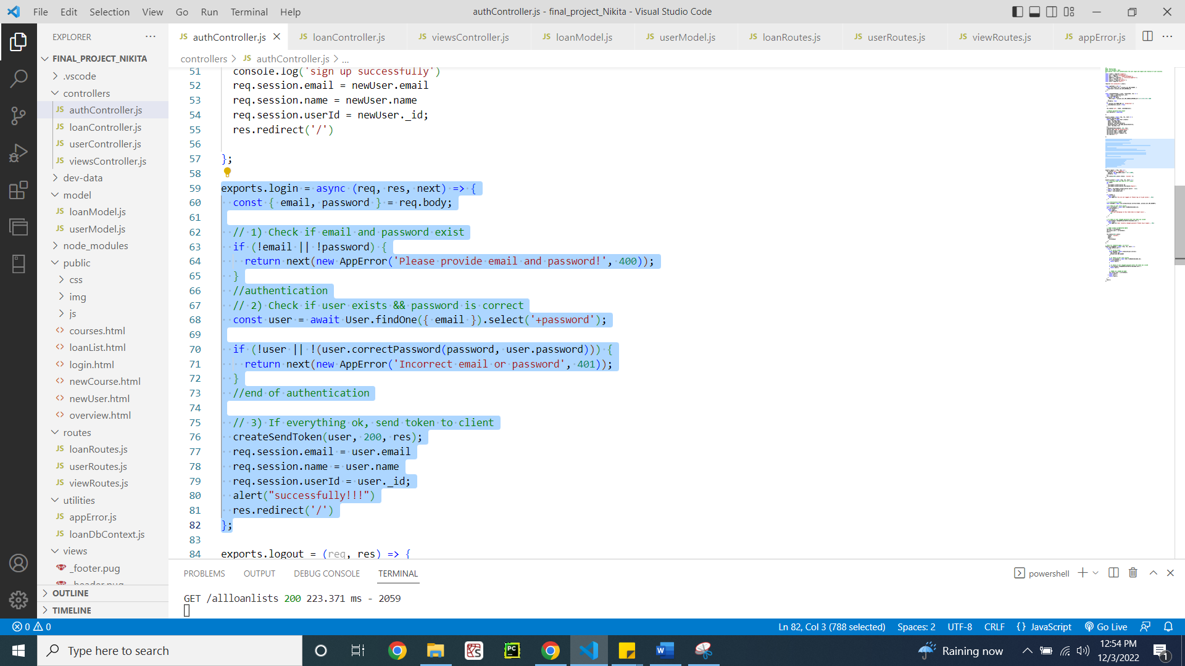

Figure 20: authController.js file for login

1. **Create New Loans**

viewRoutes.js file for the route for creating new loan (Figure 21)

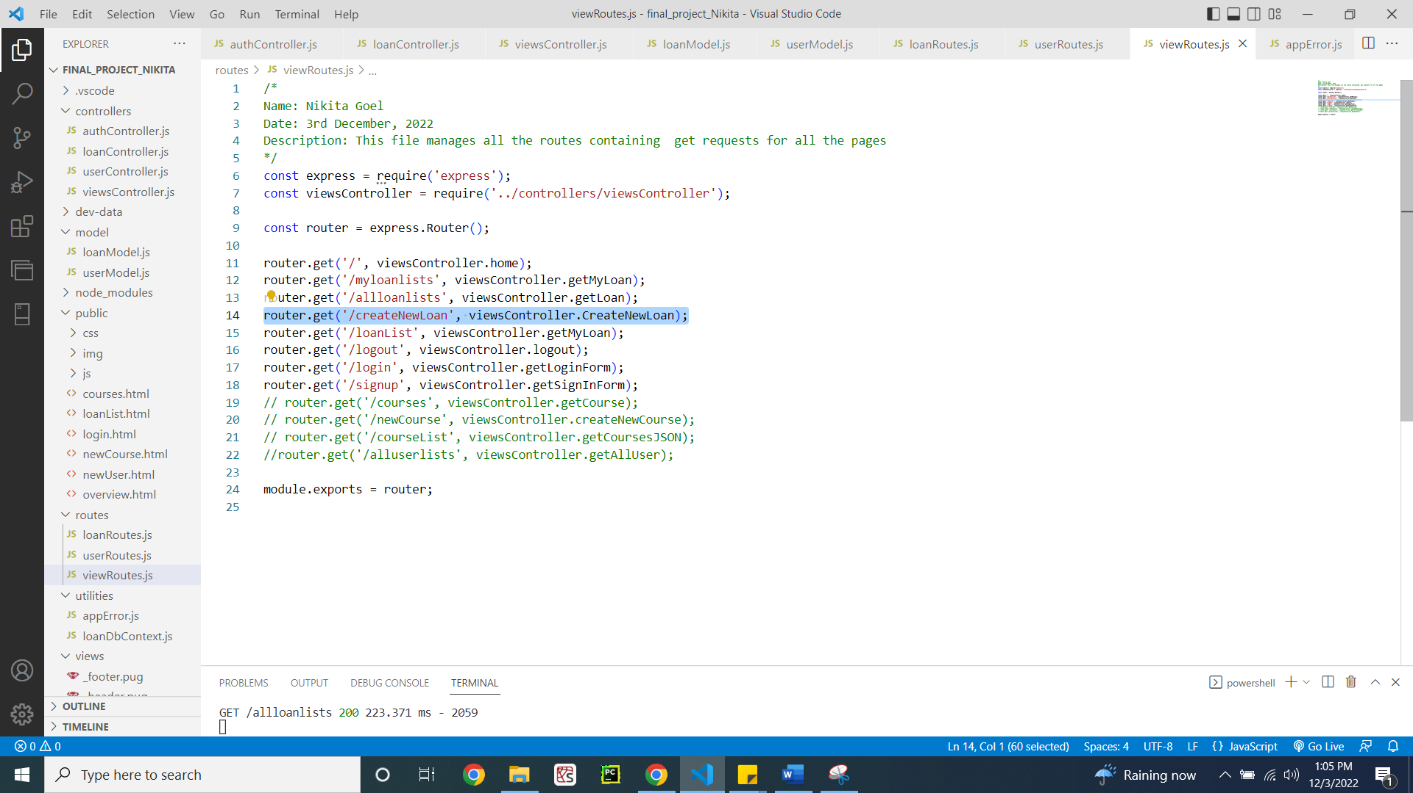

Figure 21: viewRoutes.js file for new loan

viewController.js file for implementing the route coming from the viewRoute.js (Figure 22)

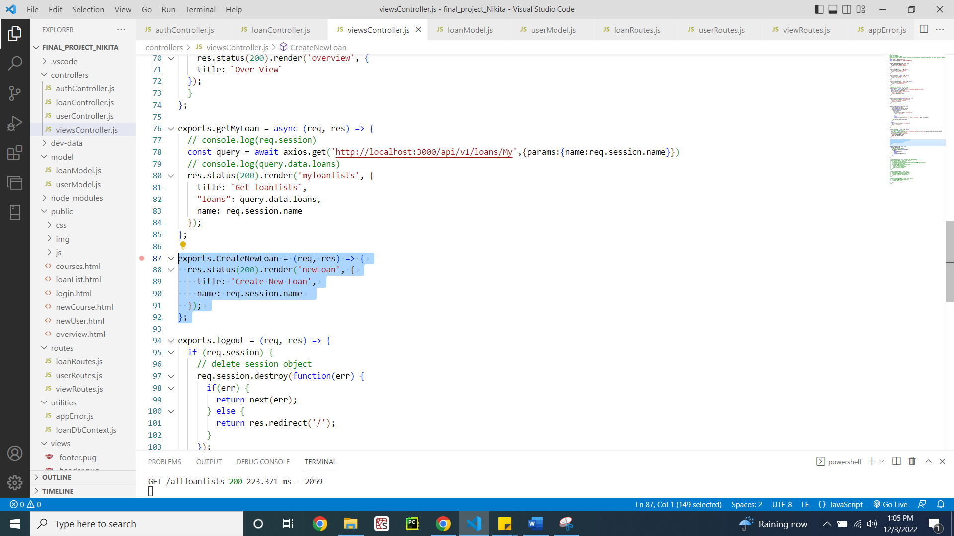

Figure 22: viewController.js file for new loan

loanRoute.js file for routing after HTML file renders back (Figure 23)

**Code:**

/*

Name: Nikita Goel

Date: 3rd December, 2022

Description: This file manages all the routes containing post and get requests for loan routes

*/

const express = require('express');

const loanController = require('../controllers/loanController');

const router = express.Router();

router

  .route('/')

  .get(loanController.getAllLoans)

  .post(loanController.createLoan, function(req, res){

    res.redirect('/');

});

router

  .route('/My')

  .get(loanController.getMyLoans)

  // .post(loanController.createLoan);

router

  .route('/:id')

  .get(loanController.getloan)

module.exports = router;

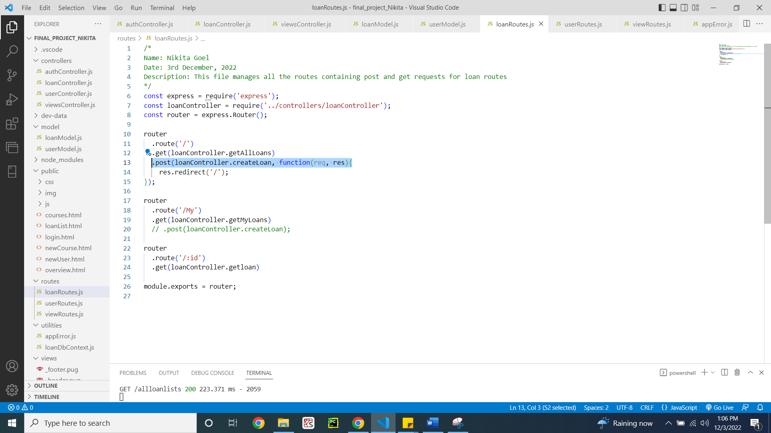

Figure 23: loanRoutes.js file for new loan

loanController.js file for implementing the creation of new loan functionality (Figure 24)

**Code:**

/*

Name: Nikita Goel

Date: 3rd December, 2022

Description: This file is setting controller for all the loan routes(Getting all loans, Getting user loan, creating, updating and deleting loans)

*/

const Loan = require('../model/loanModel');

const APIFeatures = require('../utilities/loanDbContext');

const alert =require('alert')

exports.getAllLoans =   async (req, res) => {

  console.log(req.query.name)

  try {

    // EXECUTE QUERY

    const features = new APIFeatures(Loan.find(), req.query)

      .filter()

      .sort()

      .limitFields()

      .paginate();

    const loans = await features.query;

    // SEND RESPONSE

    res.status(200).json({

      status: 'success',

      results: loans.length,

      loans

    });

  } catch (err) {

    res.status(404).json({

      status: 'fail',

      message: err

    });

  }

};

exports.getMyLoans =   async (req, res) => {

  console.log(req.query.name)

  try {

    // EXECUTE QUERY

    const features = new APIFeatures(Loan.find(), req.query)

      .filter(Loan => Loan.Name = req.query.name)

      .sort()

      .limitFields()

      .paginate();

    console.log(Loan.find);

    console.log(req.query);

    const loans = await features.query;

    // SEND RESPONSE

    res.status(200).json({

      status: 'success',

      results: loans.length,

      loans

    });

  } catch (err) {

    res.status(404).json({

      status: 'fail',

      message: err

    });

  }

};

exports.getloan = async (req, res) => {

  try {

    const loans = await Loan.find();

    //Loan.findOne({ _id: req.params.id })

    res.status(200).json({

      status: 'success',

      results: loans.length,

      data: {

        loans

      }

    });

  } catch (err) {

    res.status(404).json({

      status: 'fail',

      message: err

    });

  }

};

exports.createLoan = async  (req, res) => {

  try {

    const newLoan = await Loan.create(req.body);

    res.redirect('/')

    // res.status(201).json({

    //   status: 'success',

    //   data: {

    //     loan: newLoan

    //   }

    // })

  } catch (err) {

    res.status(400).json({

      status: 'fail',

      message: err

    });

  }

};

exports.updateLoan = async (req, res) => {

  try {

    const loan = await Loan.findByIdAndUpdate(req.params.id, req.body, {

      new: true,

      runValidators: true

    });

    res.status(200).json({

      status: 'success',

      data: {

        loan

      }

    });

  } catch (err) {

    res.status(404).json({

      status: 'fail',

      message: err

    });

  }

};

exports.deleteLoan = async (req, res) => {

  try {

    await Loan.findByIdAndDelete(req.params.id);

    res.status(200).json({

      status: 'success',

      data: null

    });

  } catch (err) {

    res.status(404).json({

      status: 'fail',

      message: err

    });

  }

};

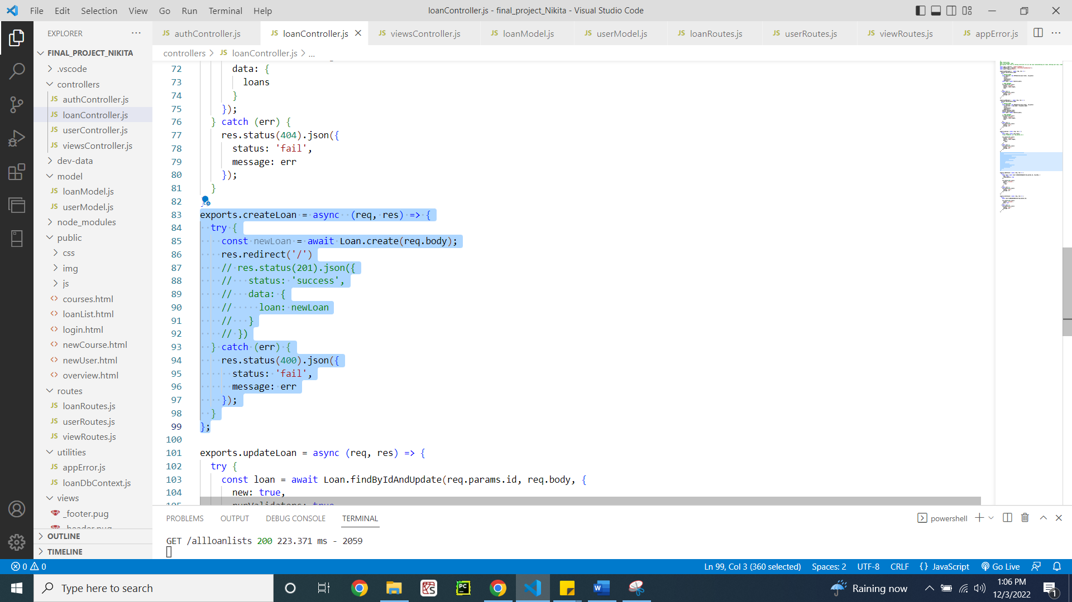

Figure 24: loanController.js file for new loan

1. **List Loan Details**

viewRoutes.js file for listing all the loans (Figure 25)

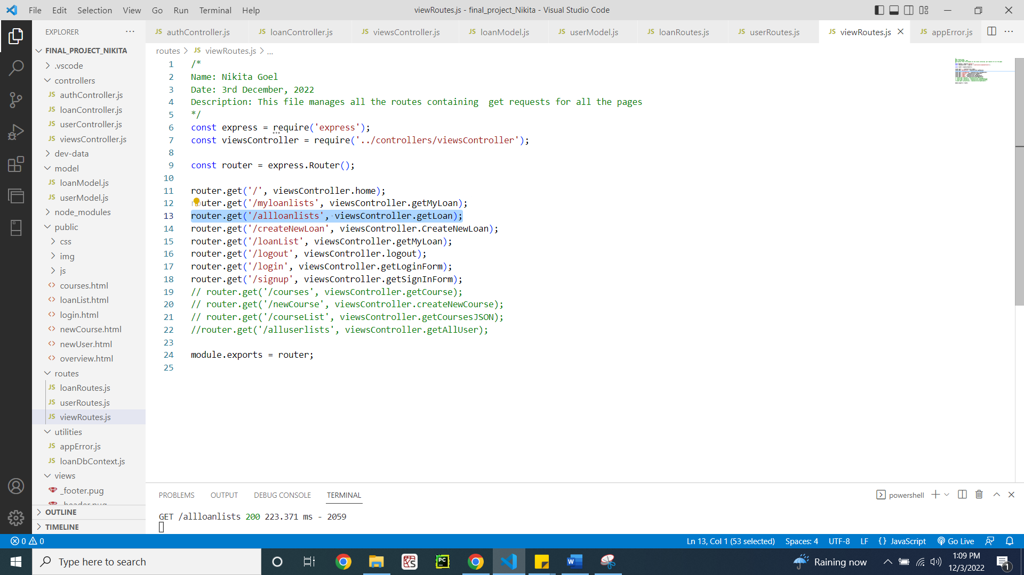

Figure 25: viewRoutes.js file for all loans

viewController.js file for listing all the loans (Figure 26)

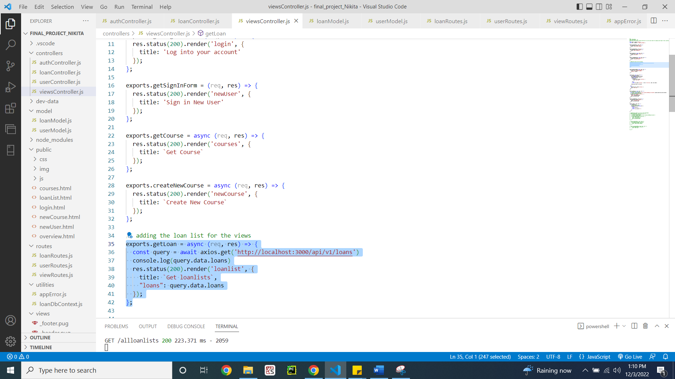

Figure 26: viewController.js file for all loans

loanRoutes.js file for listing all the loans (Figure 27)

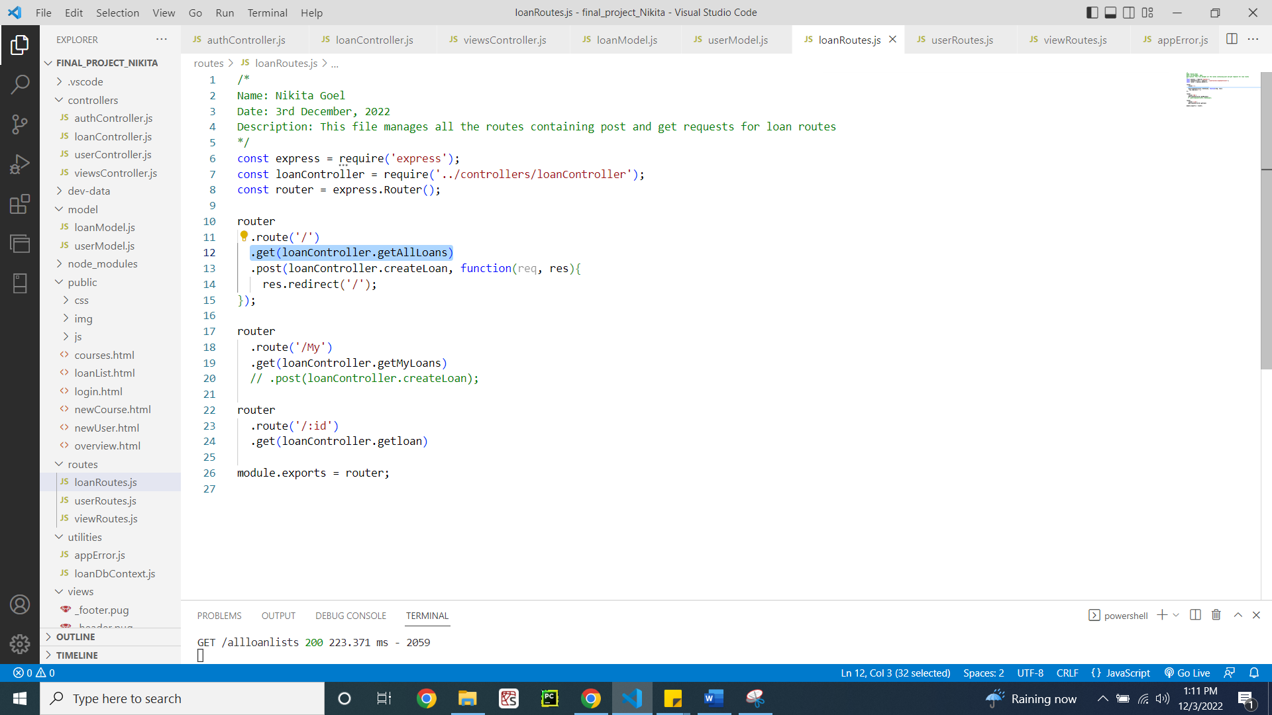

Figure 27: loanRoutes.js file for all loans

loanController.js file for listing all loans (Figure 28)

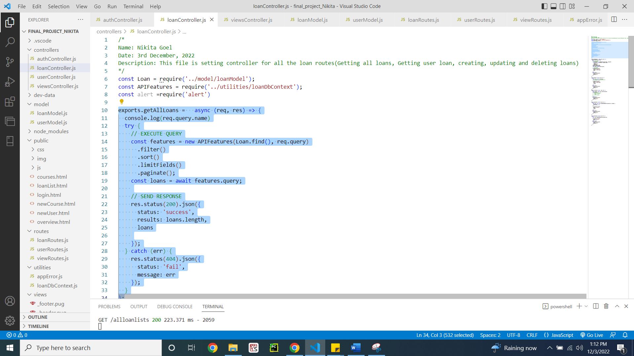

Figure 28: loanController.js file for all loans

**C: Back end**

1. **Loan Database**

Database of the loansDB MongoDB database (Figure 29)

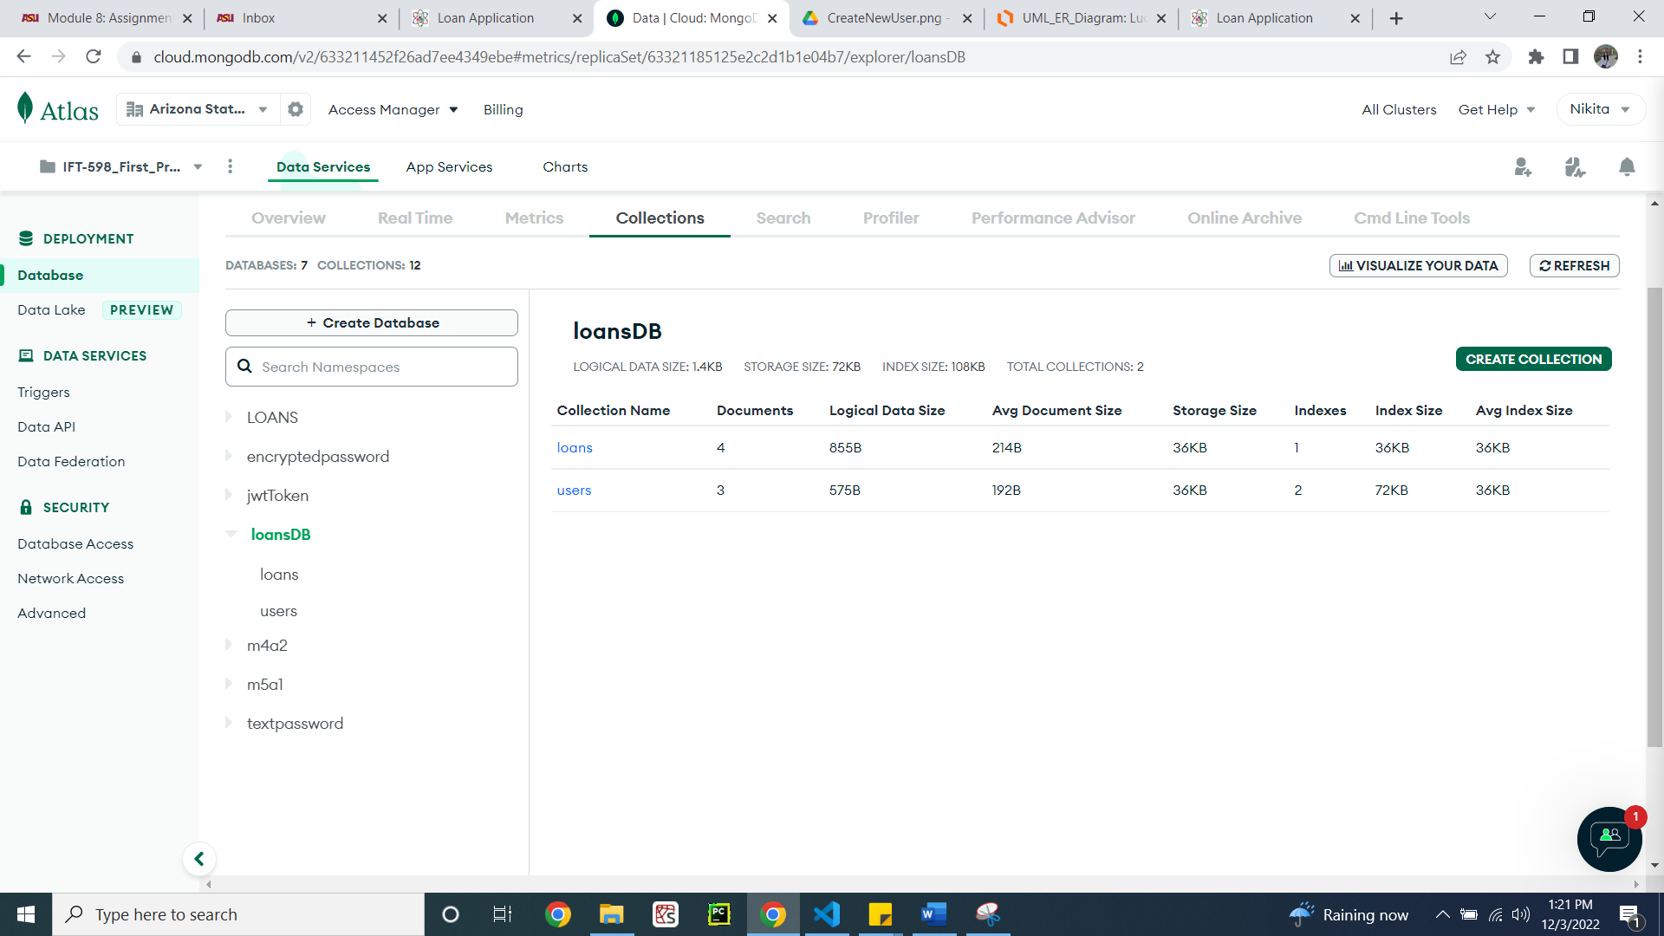

Figure 29: loansDB database

1. **User collection**

User collection having 3 users (Figure 30)

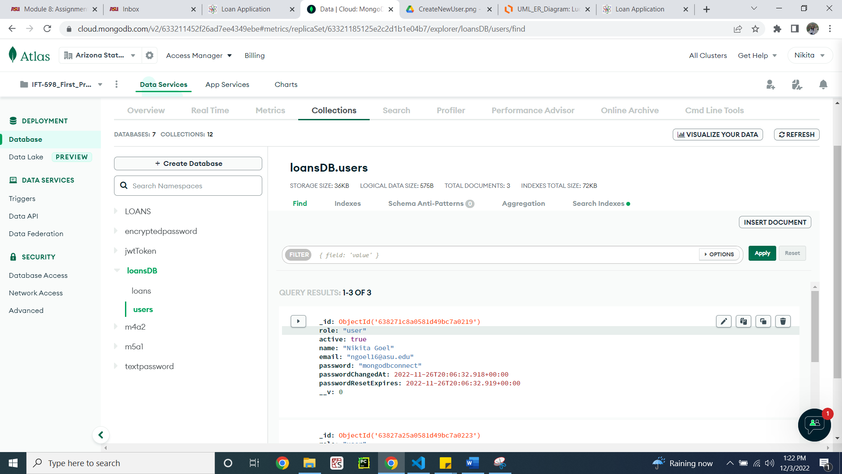

Figure 30: User collection

userModel.js file for validating user collection in database (Figure 31)

**Code:**

/*

Name: Nikita Goel

Date: 3rd December, 2022

Description: Creates the model file for user collection in the database

*/

const mongoose = require('mongoose');

// import bcryptjs

const bcrypt = require('bcryptjs');

const userSchema = new mongoose.Schema({

  name: {

    type: String

  },

  email: {

    type: String,

    unique: true,

    lowercase: true

  },

  photo: String,

  role: {

    type: String,

    enum: ['user', 'staff', 'student', 'admin'],

    default: 'user'

  },

  password: {

    type: String,

    minlength: 8,

    select: false

  },

  passwordConfirm: {

    type: String,

    // validate will only work on save or creating the user

    validate:{

      validator: function(pwd){

        return pwd === this.password;

      },

      message: " the password confirmation did not match"

  }

  },

  passwordChangedAt: {

    type: Date,

    default: Date.now

  },

  passwordResetExpires: {

    type: Date,

    default: Date.now

  },

  active: {

    type: Boolean,

    default: true,

    select: false

  }

});

// add encrypting the password middleware

userSchema.pre('save', async function(next){

  if(!this.isModified('password')){

    return next;

  }

  // if new and modified

  this.password = await this.password; // how intensive the CPU will be

  this.passwordConfirm = undefined; // we dop not want to store in database

  next();

});

userSchema.methods.correctPassword = async function(

  candidatePassword,

  userPassword

) {

  console.log(candidatePassword)

  console.log(bcrypt.compare(candidatePassword, userPassword))

  return await bcrypt.compare(candidatePassword, userPassword);

};

userSchema.methods.changedPasswordAfter = function(JWTTimestamp) {

  if (this.passwordChangedAt) {

    const changedTimestamp = parseInt(

      this.passwordChangedAt.getTime() / 1000,

      10

    );

    return JWTTimestamp < changedTimestamp;

  }

  // False means NOT changed

  return false;

};

userSchema.methods.createPasswordResetToken = function() {

  const resetToken = crypto.randomBytes(32).toString('hex');

  this.passwordResetToken = crypto

    .createHash('sha256')

    .update(resetToken)

    .digest('hex');

  // console.log({ resetToken }, this.passwordResetToken);

  this.passwordResetExpires = Date.now() + 10 * 60 * 1000;

  return resetToken;

};

const User = mongoose.model('User', userSchema);

module.exports = User;

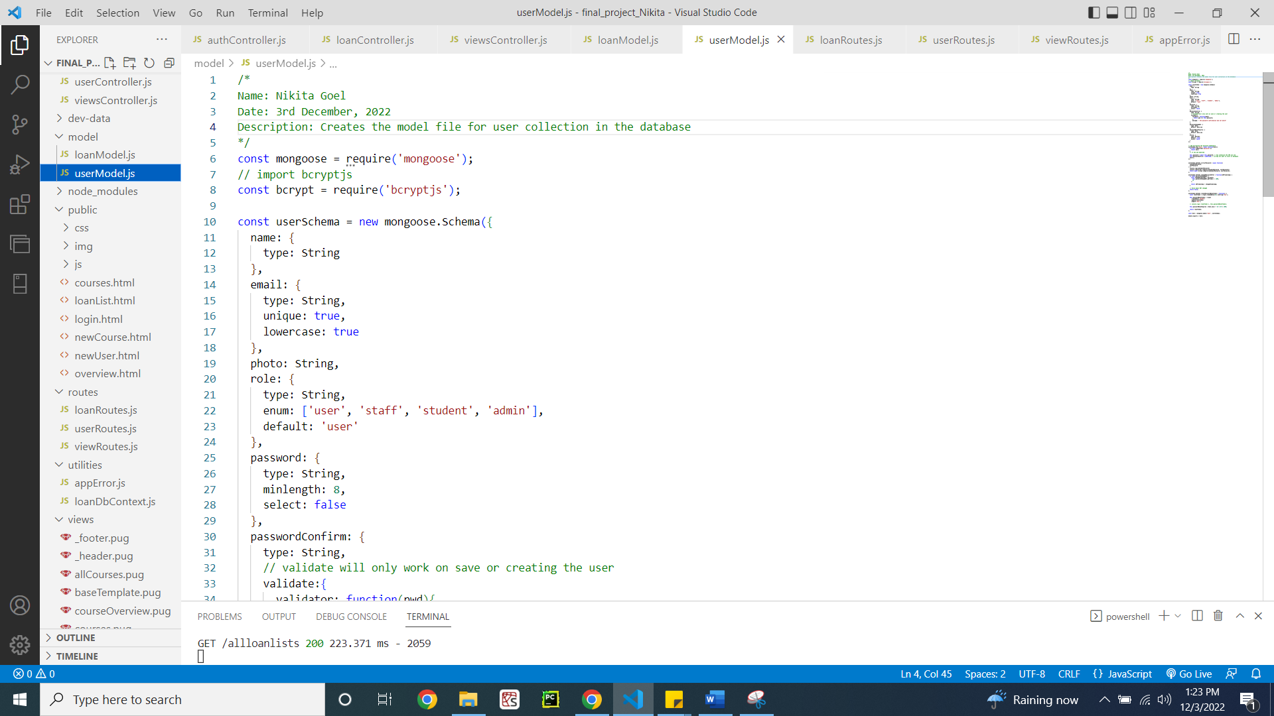

Figure 32: userModel.js file

1. **Loan collection**

Loan collection having 4 loans (Figure 33)

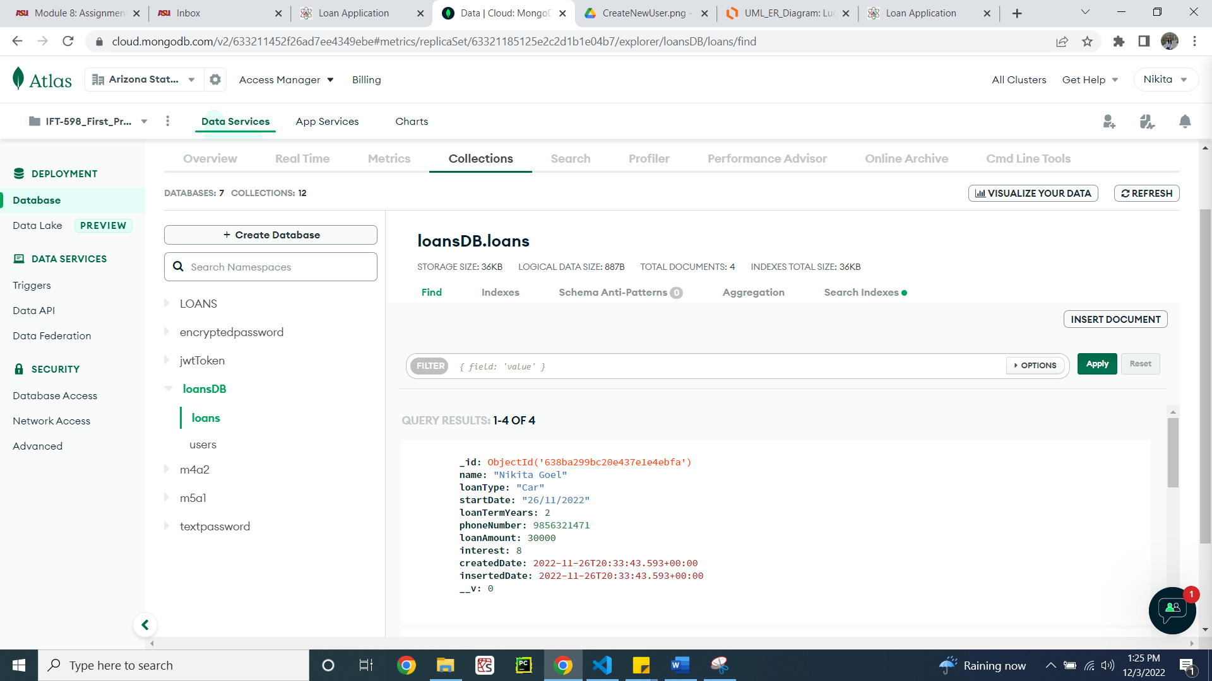

Figure 33: Loan collection

loanModel.js file for validating loan collection in database (Figure 34)

**Code:**

/*

Name: Nikita Goel

Date: 3rd December, 2022

Description: Creates the model file for loan collection in the database

*/

const mongoose = require('mongoose');

const loanSchema = new mongoose.Schema(

  {

    name: {

        type: String,

        required: [true, 'A customer must have a name'],

        trim: true,

        maxlength: [40, 'A customer name must have less or equal then 40 characters'],

        minlength: [10, 'A customer name must have more or equal then 10 characters']

    },

    phoneNumber:{

        type: Number,

        validate: {

            validator: function(value){

                return value.toString().length === 10;

            }

        }

    },

    address: {

        type: String,

        trim: true,

        maxlength: [70, 'An address  must have less or equal then 70 characters'],

        minlength: [10, 'A from  must have more or equal then 10 characters']

    },

    loanAmount: {

        type: Number,

        required: [true, 'A loan should have loan amount']

    },

    interest: {

        type: Number,

        required: [true, 'A loan should have loan interest'],

        validate: {

            validator: function(value){

                return value.toString().length < 4;

            }

        }

    },

    loanTermYears: {

        type: Number,

        required: [true, 'A loan should have loan term years'],

    },

    loanType: {

        type: String,

        required: [true, 'A loan must have a type'],

        enum: ['Car', 'Home', 'Personal', 'Education']

    },

    description: {

        type: String,

        trim: true,

        maxlength: [100, 'A description  must have less or equal then 100 characters'],

        minlength: [5, 'A description  must have more or equal then 5 characters']

    },

    startDate: {

        type: String,

        required: [true, 'Loan should have a start date']

    },

    createdDate: {

        type: Date,

        default: Date.now

    },

    insertedDate: {

        type: Date,

        default: Date.now

    }

});

const Loan = mongoose.model('Loan', loanSchema);

module.exports = Loan;

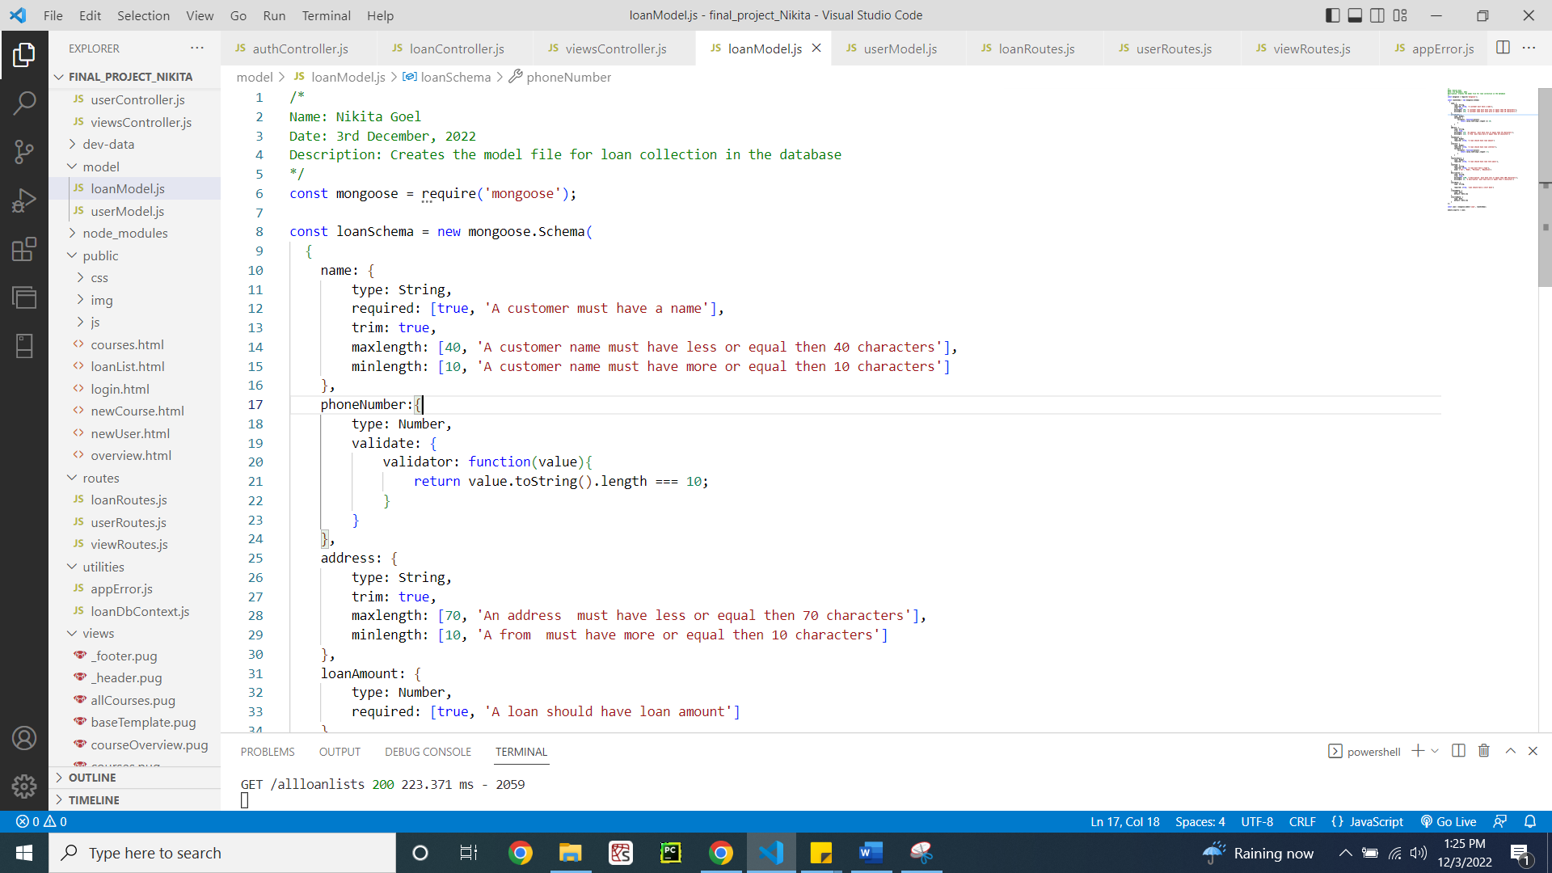

Figure 34: loanModel.js file

**Project output**

Landing page (Figure 35)

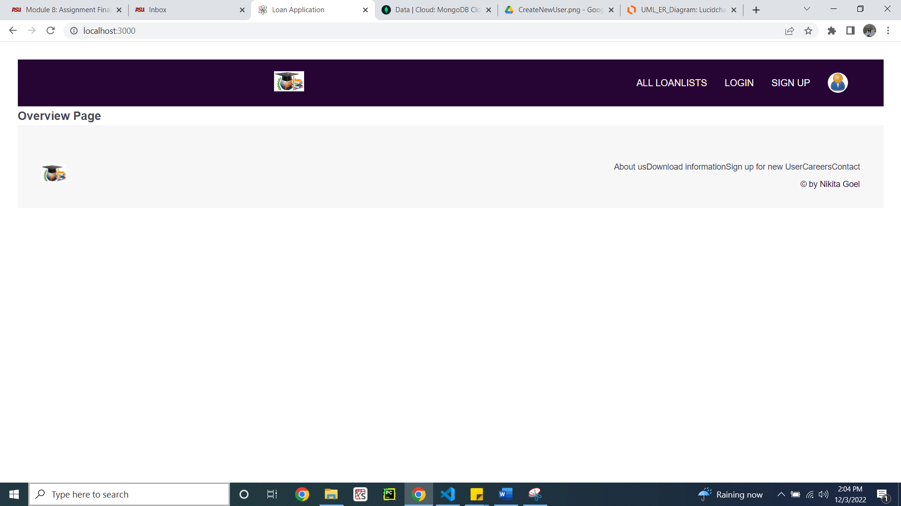

Figure 35: Overview page

Signing up a new user (Figure 36)

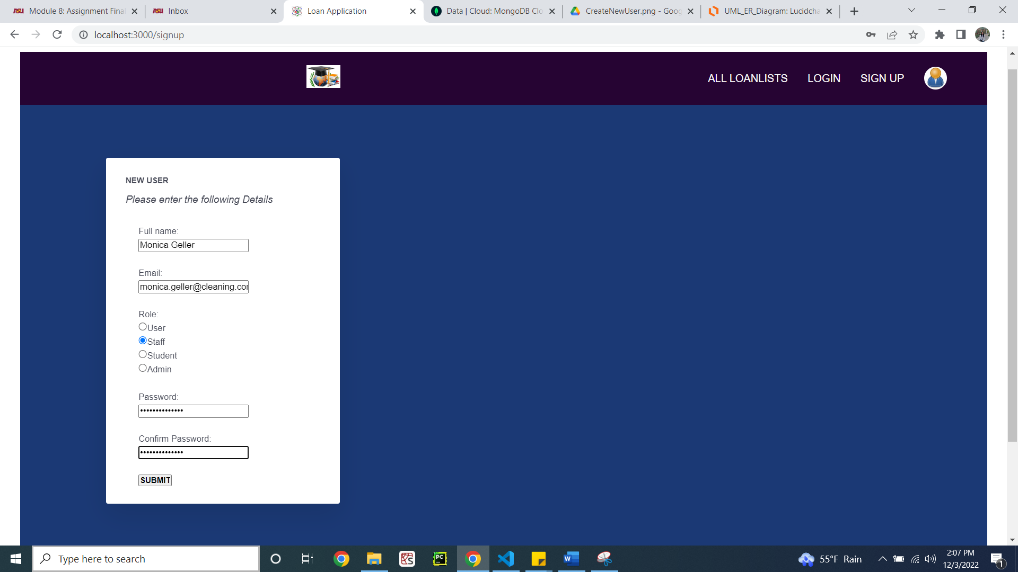

Figure 36: Creating a new user

Successfully logged in, and logged in with the name of the user (Figure 37)

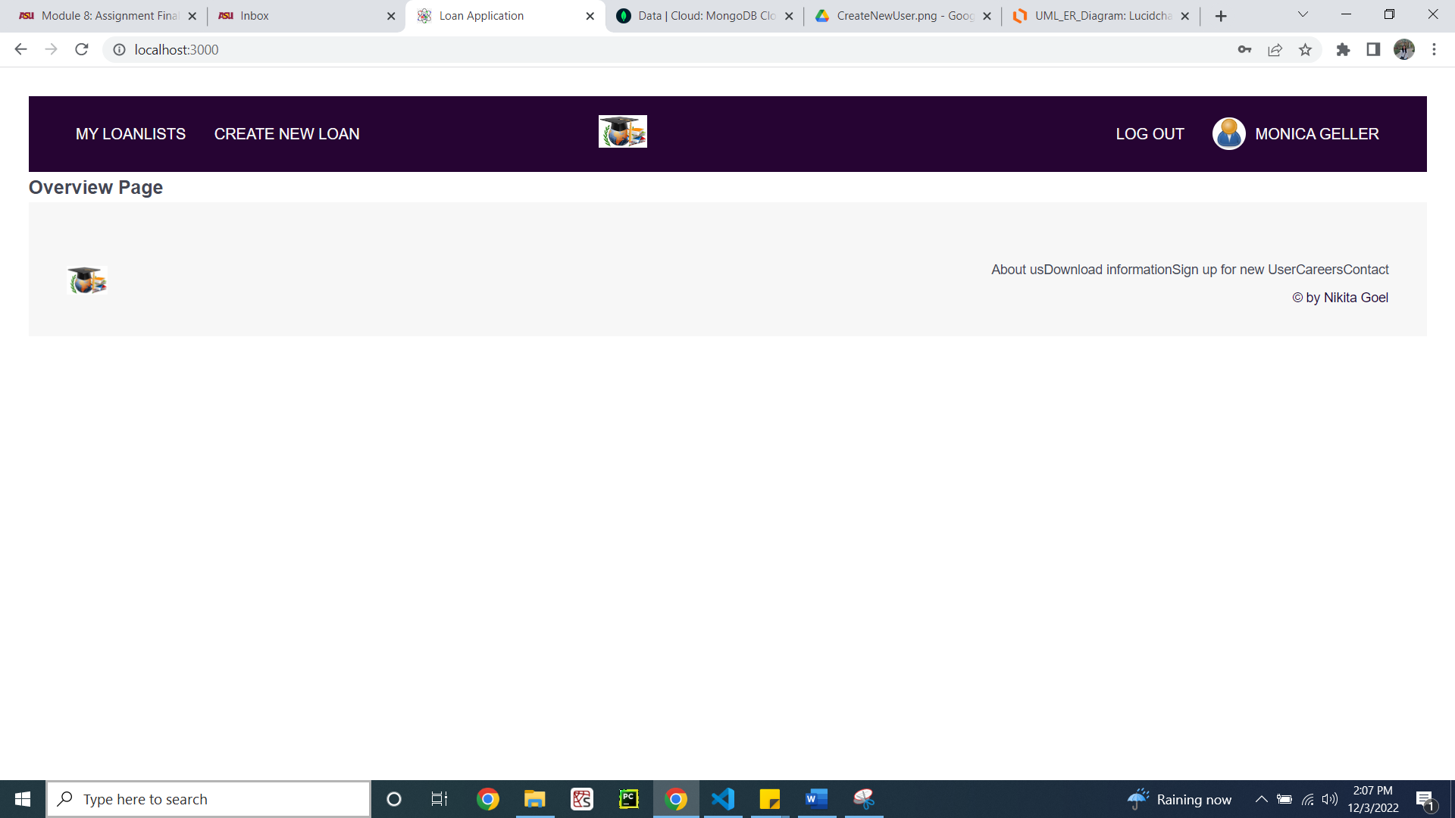

Figure 37: Login of the new user

MongoDB collection showing new user (Figure 38)

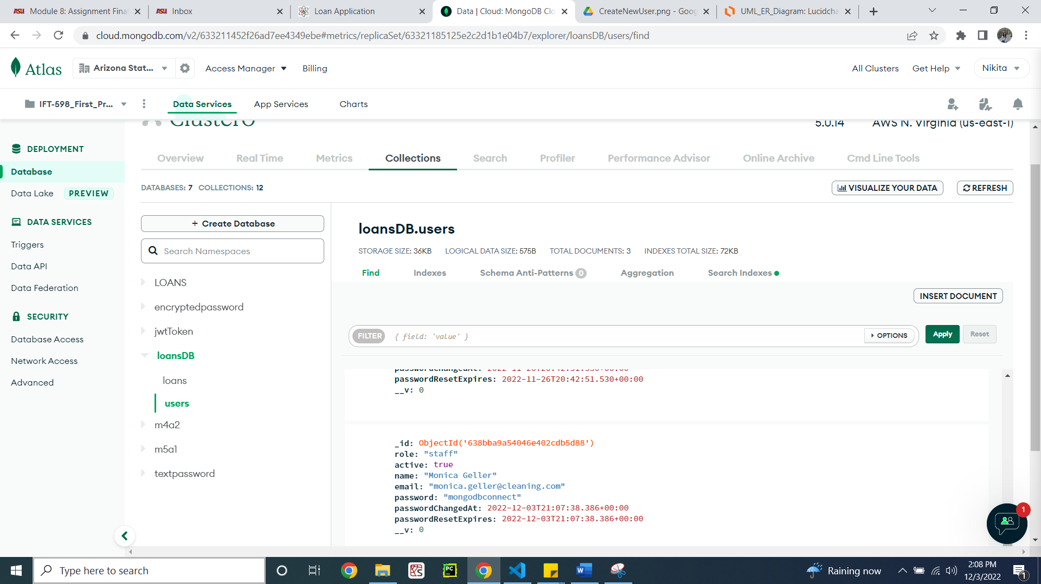

Figure 38: MongoDB user collection

Create a new loan (Figure 39)

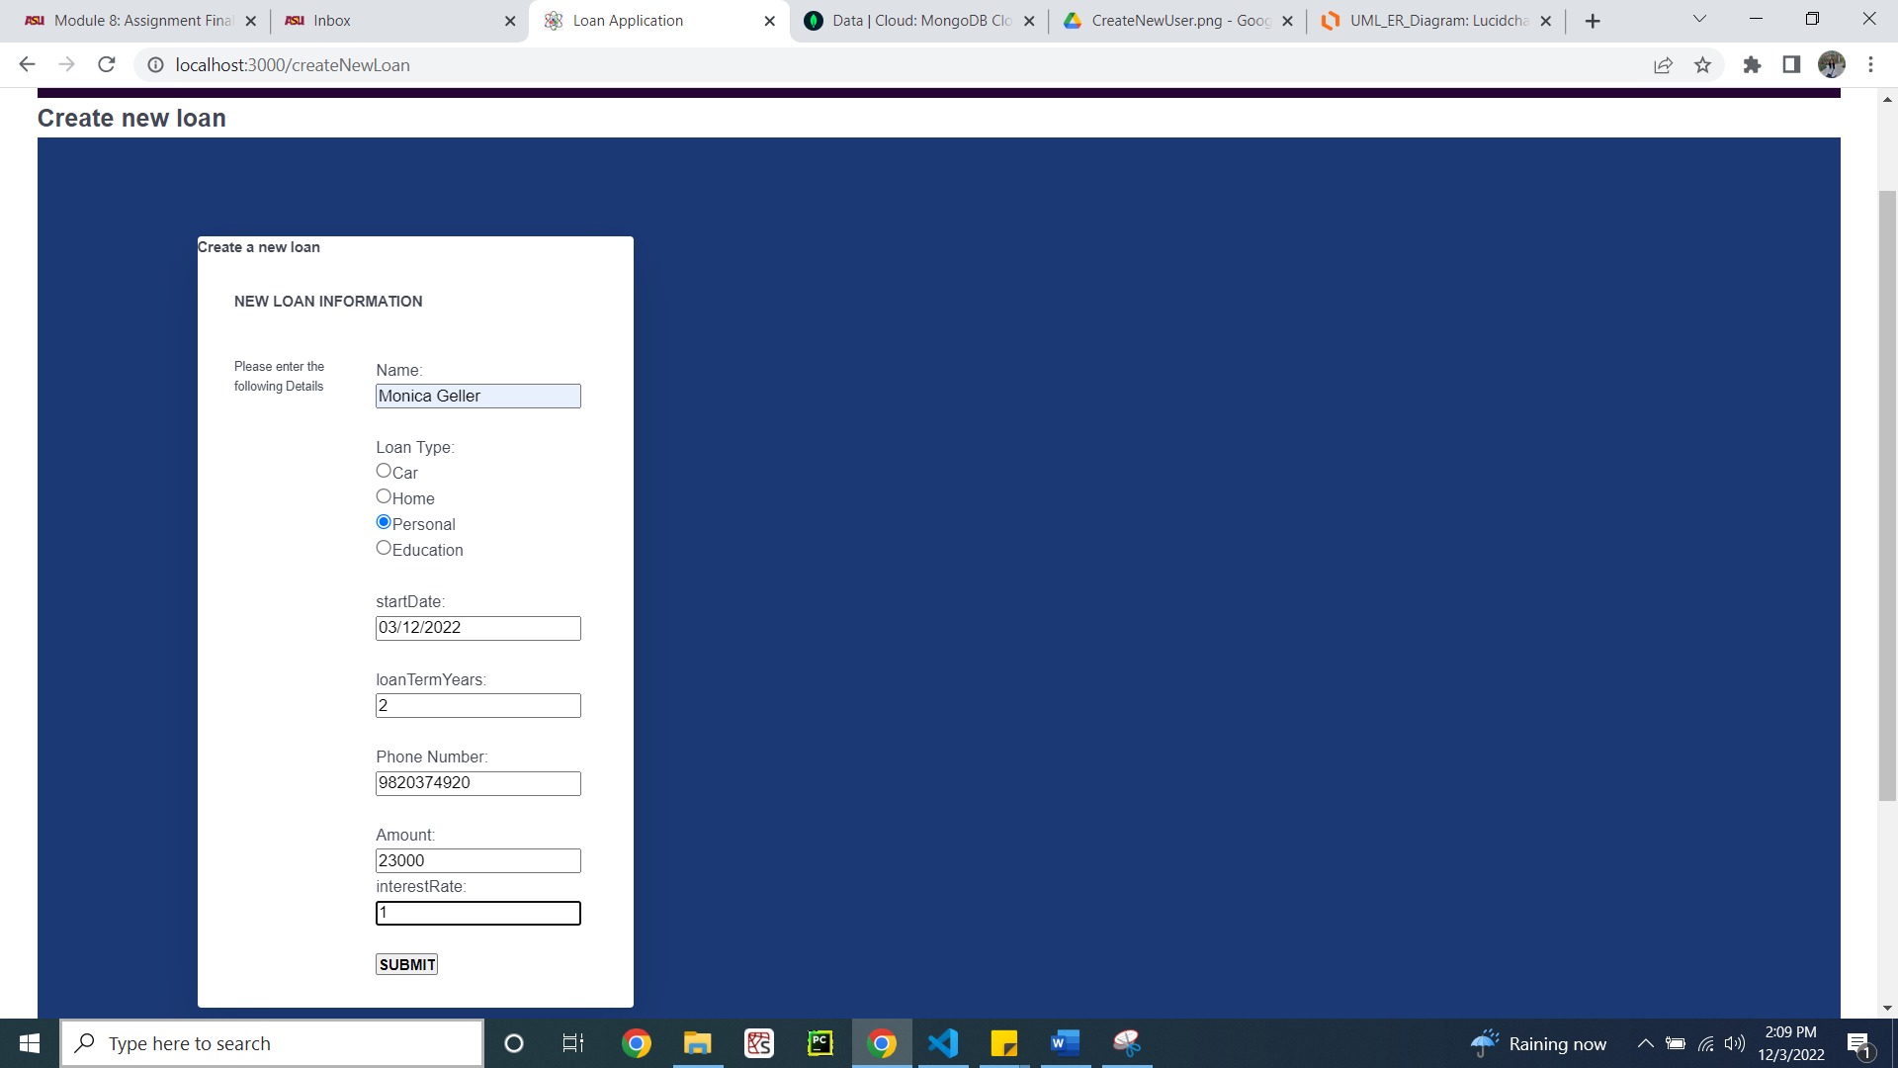

Figure 39: Creating new loan

MongoDB collection showing new loan (Figure 40)

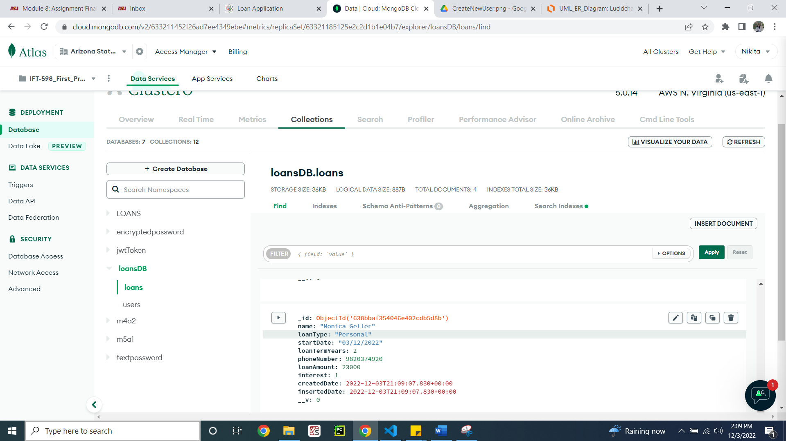

Figure 40: MongoDB loan collection

Listing the loans of the logged in user (Figure 41)

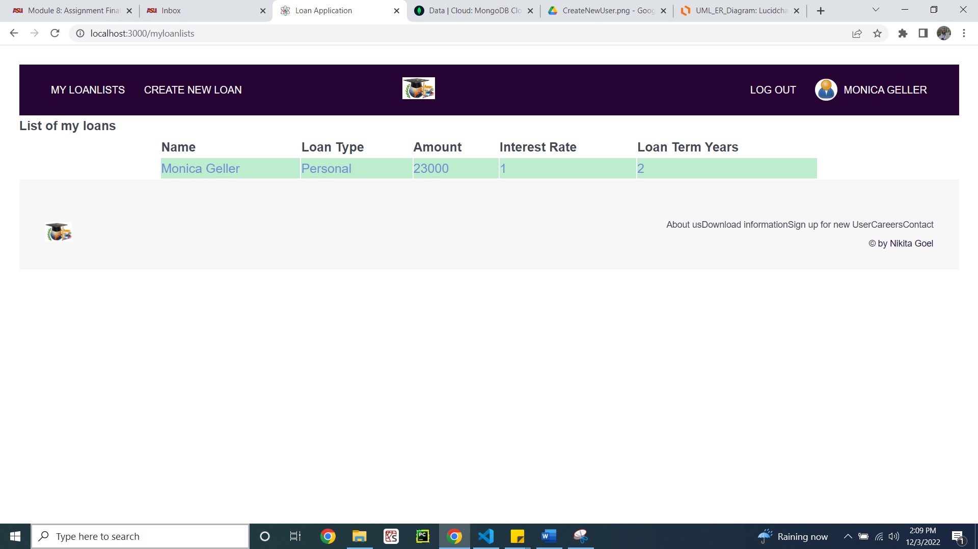

Figure 41: Listing the loans of the user

Listing all the loans (Figure 42)

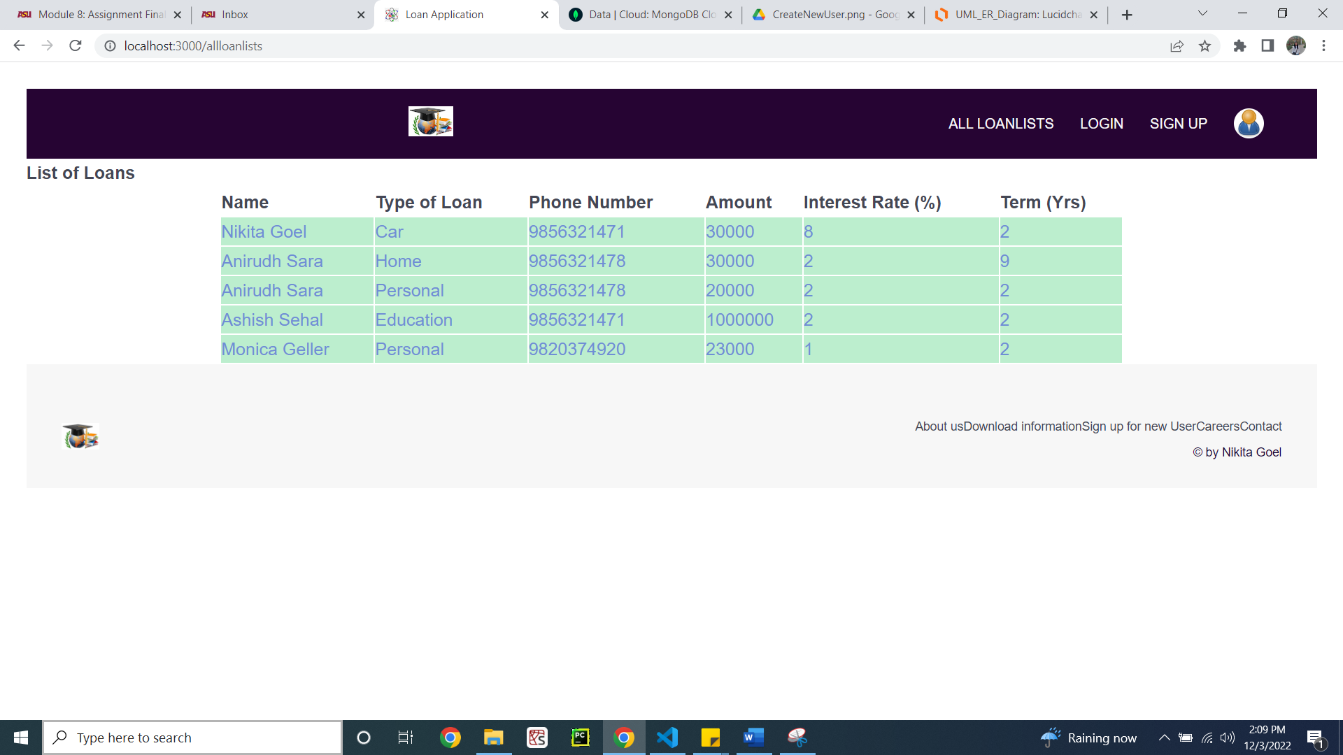

Figure 42: Listing all the loans from the database

**Testing with POSTMAN**

POSTMAN collection for signing up new user (Figure 43)

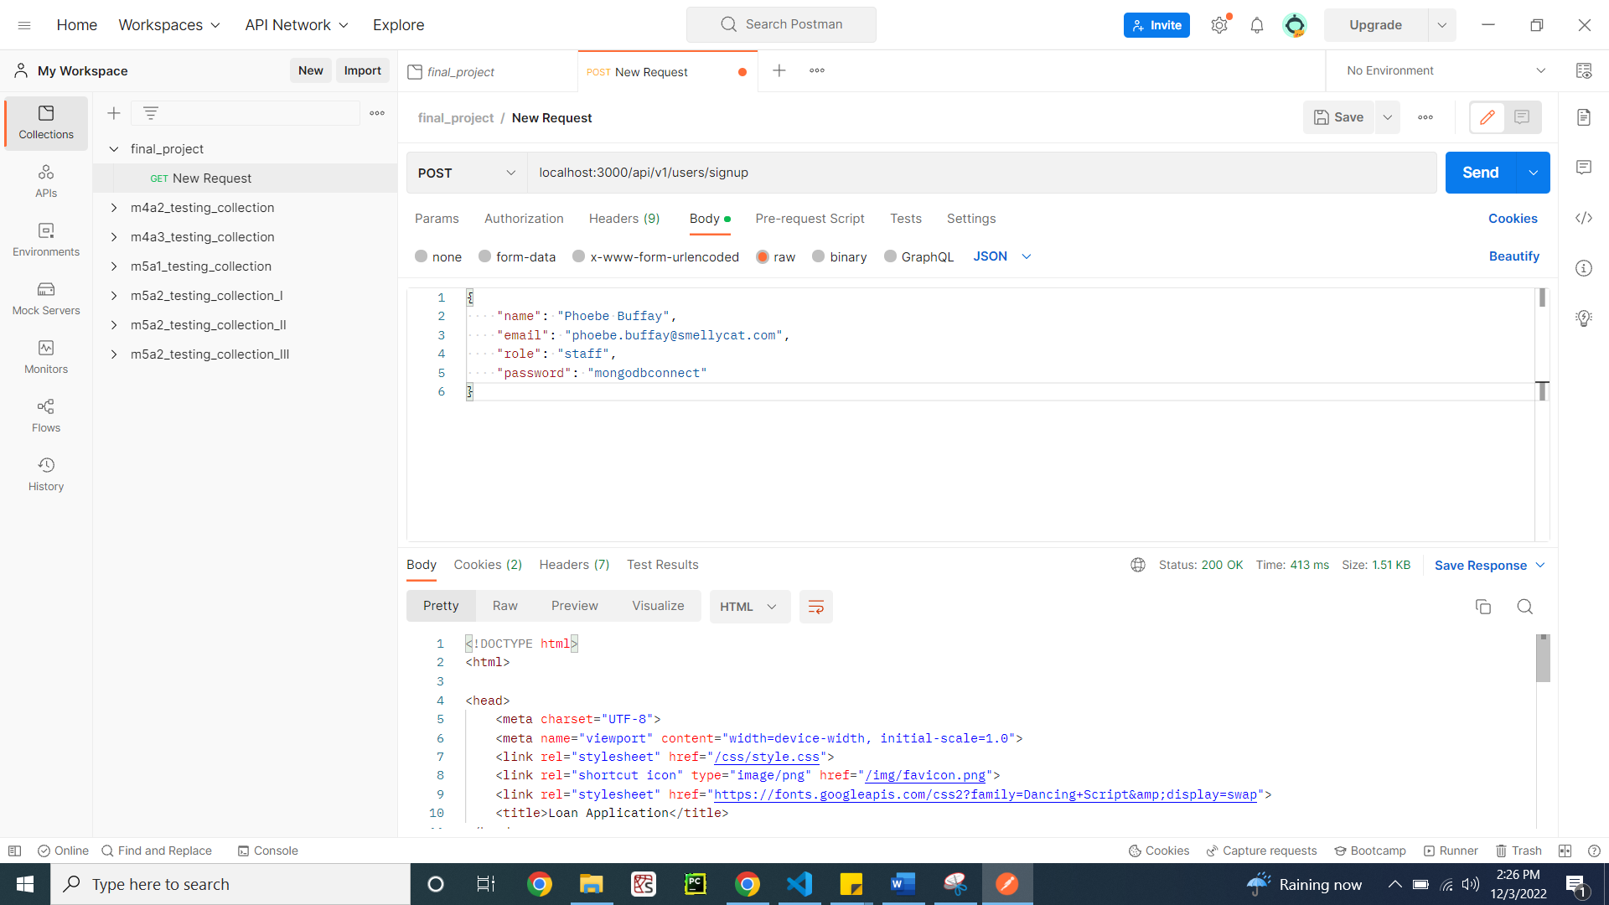

Figure 43: Test successful

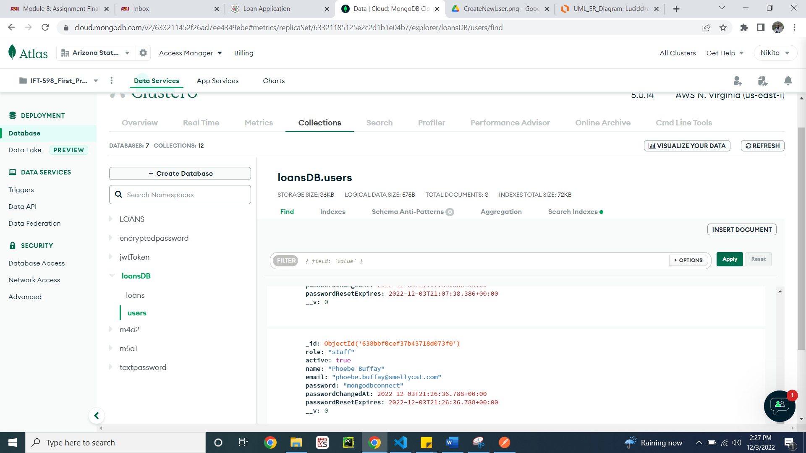

Figure 44: New user got added into the database

Listing all the users – just for testing purpose. This feature is not included in the application (Figure 45)

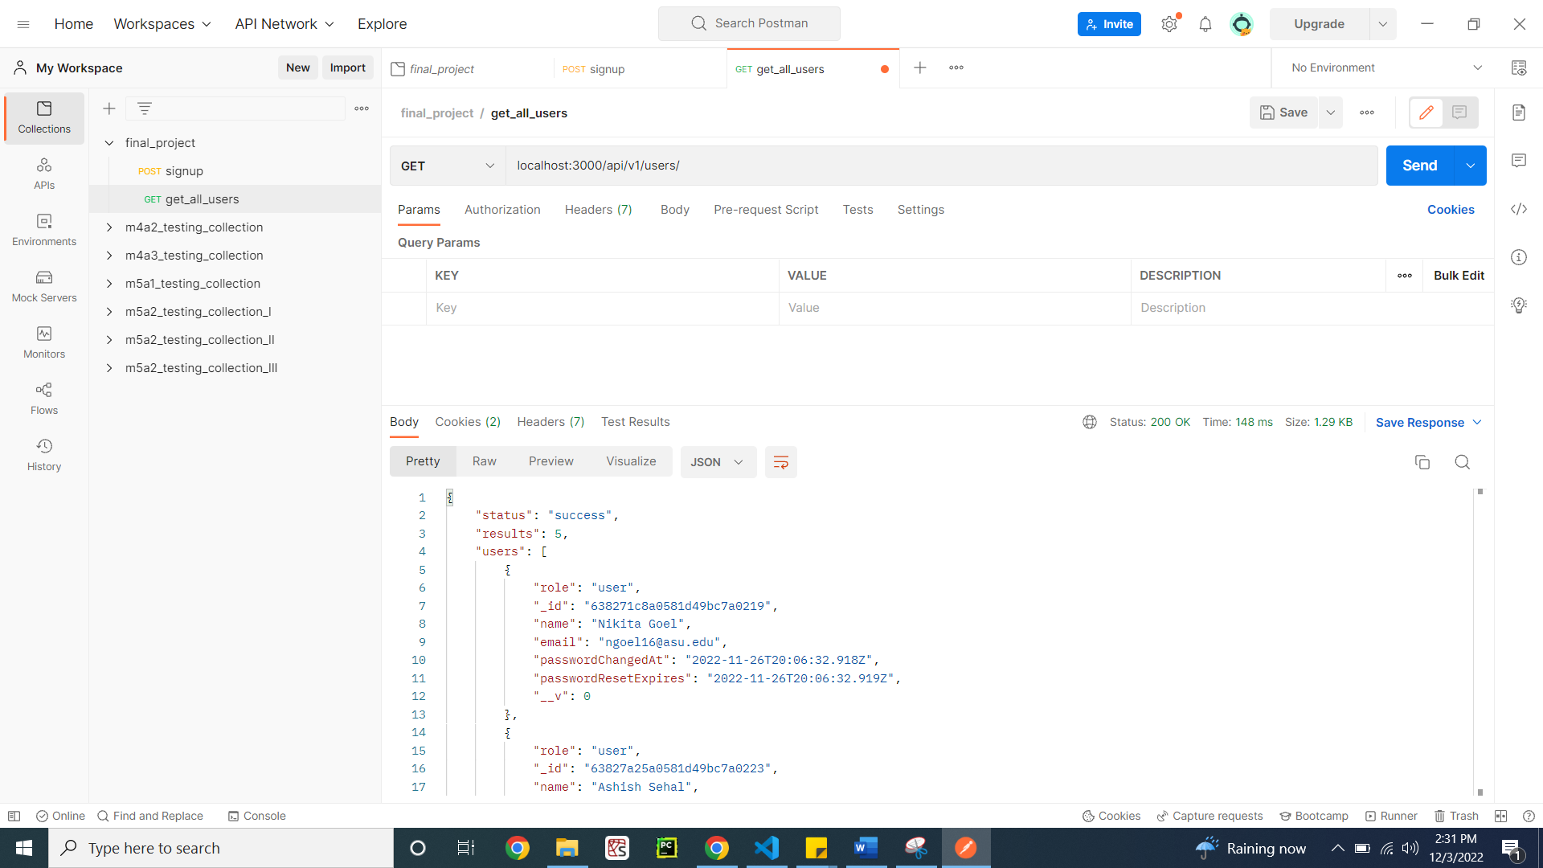

Figure 45: Listing all users

Creating a new loan for an existing user (Figure 46)

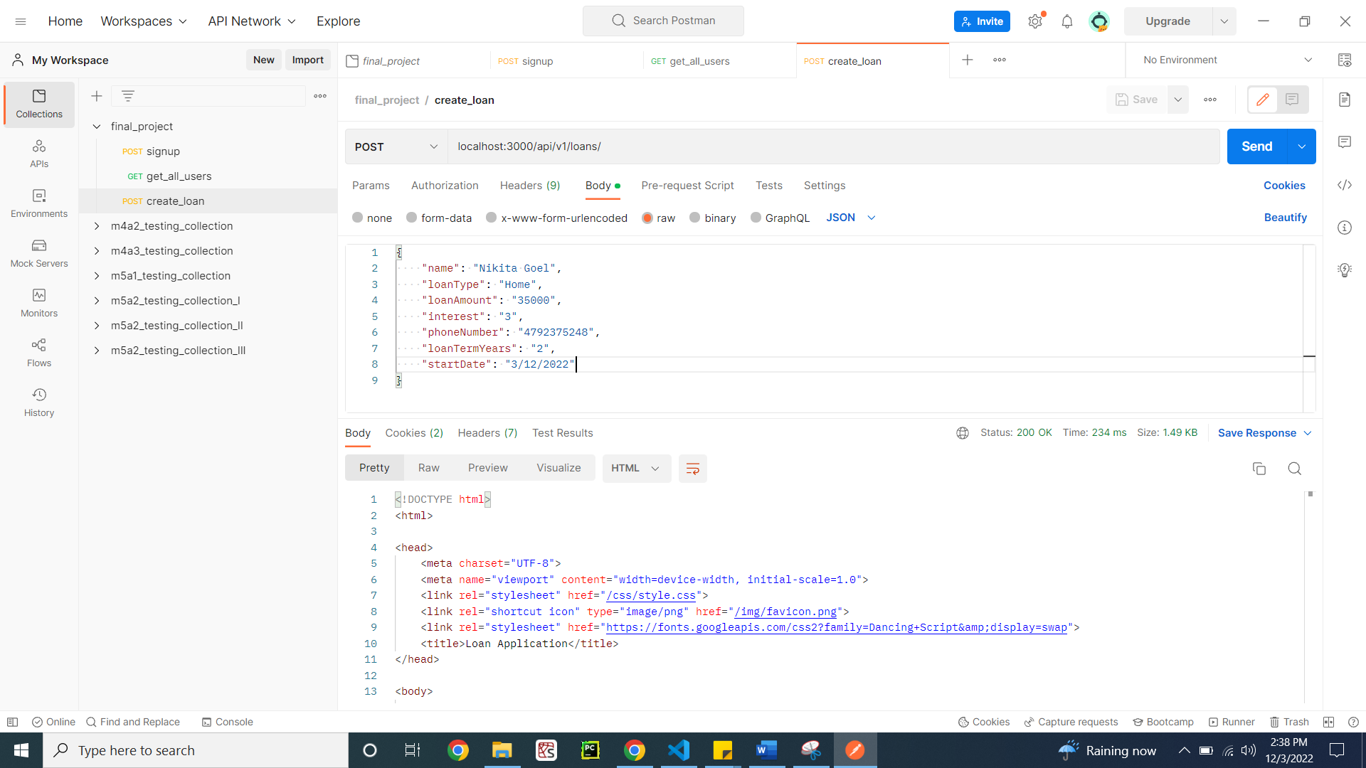

Figure 46: Test successful

Getting all the loans from the database (Figure 47)

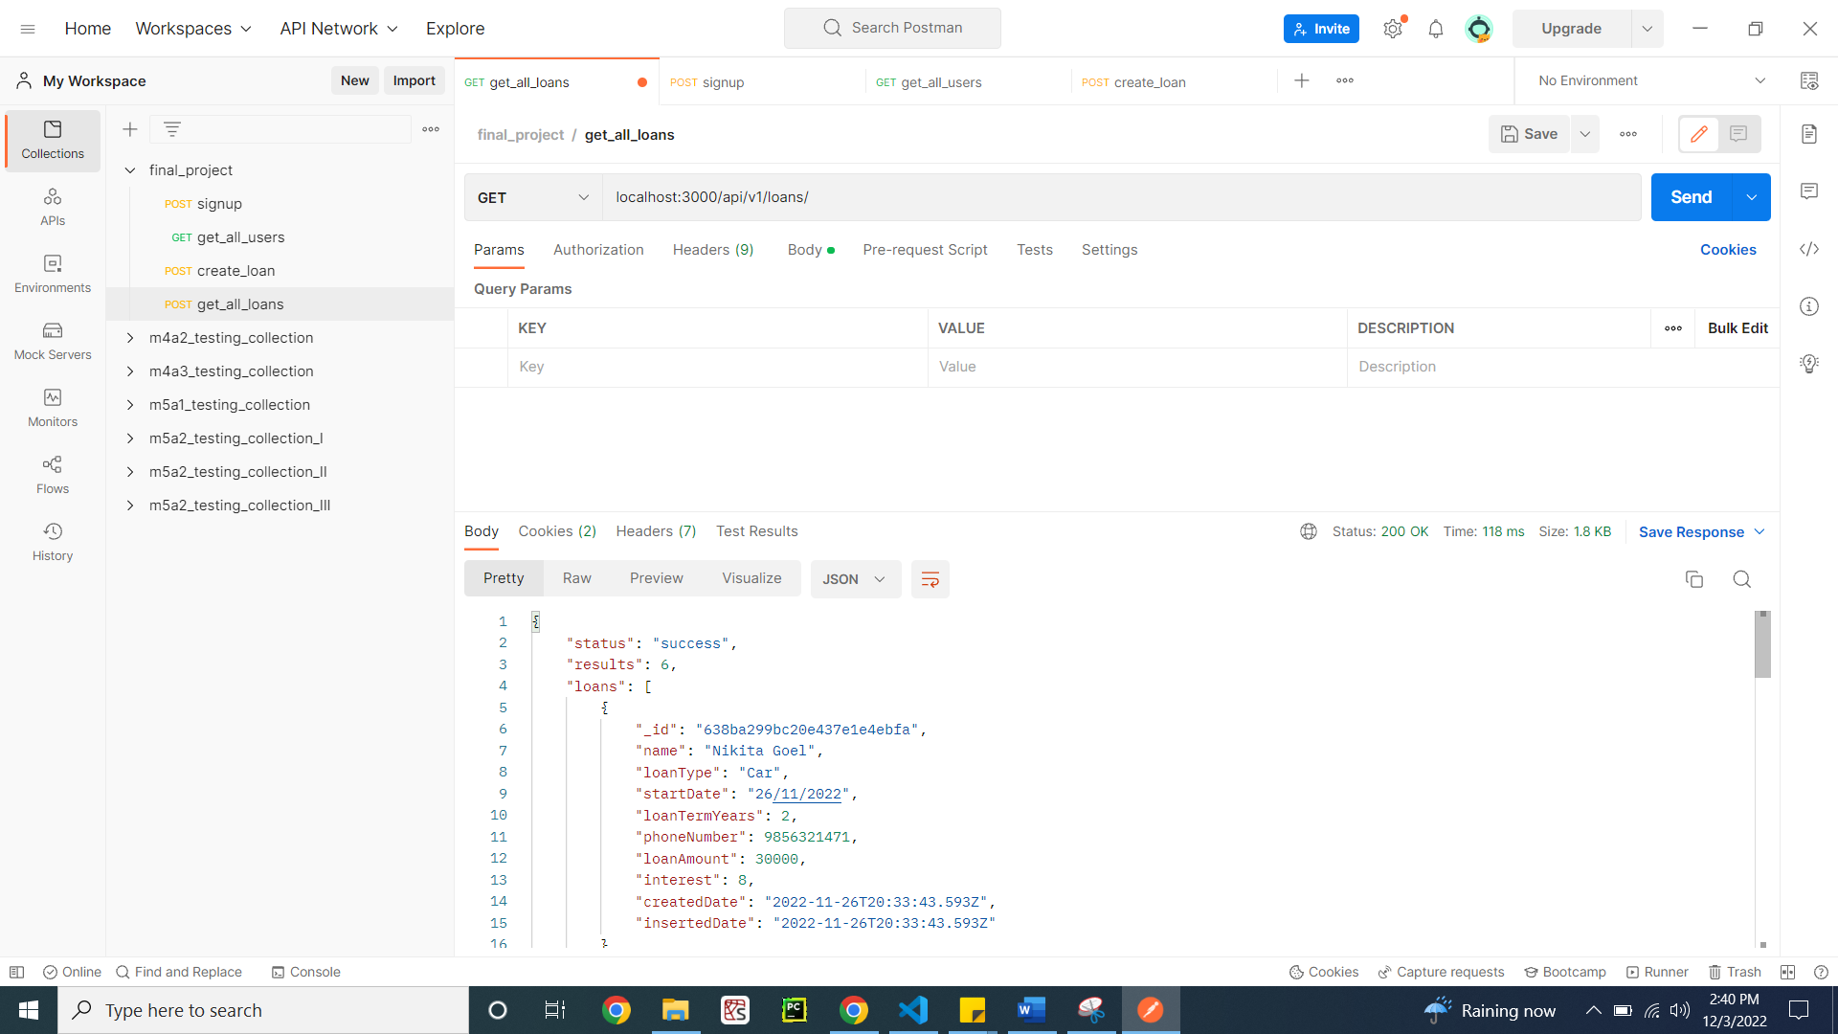

Figure 47: Test successful

**Project Design**

This project consists of a full stack web application connected with MongoDB database. The front-end UI consists of an overview page, with sign up and sign in functionality. The application also allows users to create new loans for themselves which means they have applied for new loans with the bank. To keep track of what loans they have taken and checking their loan information they can access their loans. A user who has not logged in can see all the loans also.

The project consists of the main file that starts the application and connects to the database (server.js). The app.js consists of starting routes that redirect the backend to frontend. The middleware consists of routes and controllers that control the implementation of each page whose route the application redirects to. In the routes, there is viewRoutes.js file that redirects the client to the middleware application and renders the HTML to the client. Once the client chooses the options on the screen, if the options consist of user-related options like sign up of user etc. it redirects it to the userRoute.js routes. If it is related to loan, it will get redirected loanRoutes.js. The userRoutes.js redirects the route implementation to authController.js which implements authentication to the user when signing in, creating new and logging out of user happens.

The UI frontend is coded using PUG files for each HTML route and CSS for each page is modularized into one CSS folder. All the images of the frontend are contained in the images folder and whenever needed the PUG files access these.

The MongoDB database consists of Loans DB database comprising of users and loans collections. The user collection consists of user information like the name, email, password and roles of the user. The loan collection consists of loan information of user based on their name. The loan collection consists of loan type, loan amount, interest of the loan etc.

**Risks and out of scope functionality**

Risks of the project:

* The project can implement a more sophisticated approach to make the authentication process more secure while the user is logged in or any application related change can impact the database.
* Once the user logs in, better session management needs to be implemented to restore the period of login.

Out of scope functionality:

* The scope of the project can include authorizing the users and providing additional actions based on their role. For example, the admin can get access to see all the loan list.
* The project can be enhanced to add notification to the user about the loan due for them to initiate the payment of loan.

**Project estimate**

The project estimate for this project can be based on the requirements gathered from the business. This project can take up to 8 weeks to complete, assuming the developers have had experience with the technology chosen by them. The 8 weeks can be divided to perform the design finalization, full stack implementation, adding authentication and security and to complete all the testing.

**Learning experiences from module 1 to 8 progress:**

Module 1 was the introductory module which introduced me with JavaScript and how the backend gets connected to the frontend. I learnt how to read JSON data and output it on the front end. This helped me in getting to know how the server works and how the front end gets connected to the back end.

Module 2 helped me get a better understanding of data types and syntax of the JavaScript. I created a function in JavaScript. In module 3 I got introduced to different data formats in JavaScript, external modules, and content negotiation. I also learned how to connect SQL server with JavaScript. I learnt to create sophisticated ER diagrams.

Module 4 helped me in understanding how MongoDB in cloud works. I followed the instructions on the professor which helped in getting more insights about the MongoDB database framework. I learnt how to create effective database design, how to set up the MongoDB on cloud and how to create NoSQL database in MongoDB Atlas.

Module 5 helped me in understanding how to effectively test the code using POSTMAN and I tested the Java Web token authentication flow. I learnt the importance of security while encrypting the password when saving it in the database using the JWT token.

Module 7 introduced me to the PUG file creation and how HTML code can be made more modularized. The PUG file should be modular in design rather than in-line documents. I created a sign up and sign in page in PUG and tested it in full stack.

Module 8 helped me in collecting all my learnings and accumulate all the codes from all the modules and develop a complete web application for users in banking domain.

**GitHub repository:**

**References**

Videos of the professor for all the modules

Links of the web pages attached by the professor in every assignment

Mongoose documentation: <https://mongoosejs.com/docs/api.html>

JavaScript Documentation: <https://developer.mozilla.org/en-US/docs/Web/JavaScript>

PUG file documentation: <https://pugjs.org/api/getting-started.html>